http://dont-tread-on.me/the-silver-bullet-and-the-silver-shield

The Silver Bullet And The Silver Shield
By Silver Shield, on February 25th, 2011

The Ultimate FREE Silver Investors Guide.
Two of the most common questions I get inside of the Sons of Liberty Academy focus on two things. How to turn back the tide of this increasingly corrupt system and how to financially prepare for a post-dollar world. This does not surprise me, since fear and greed are the two most powerful motivators known to man. What will surprise you, is that for once, the answer to both questions, is the same answer.
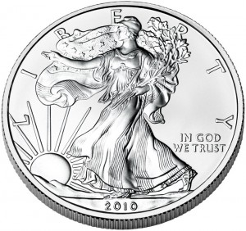Buying physical silver is by far the greatest act of wisdom and rebellion any American can and should be doing right now. It is both a Silver Bullet to rebel against the Elite’s corrupt system and a Silver Shield to protect your family and wealth in a post- dollar world. Buying physical silver is non-violent, non-compliant resistance. Most importantly it works outside of the system and it cannot be stopped.
“As long as you play by the Elite’s rules, the Elite will rule.” -Chris Duane
Any effort trying to work within the Elite’s paradigm, will fail. The Tea Party march on Washington failed. It failed like the 2010 Tea Party Congressional campaign. If failed because nothing happened, and nothing changed. That is not to say they were not great exercises in power. It just will never bring about any real change because awareness campaigns and marches are not enough. The Elite that control our reality don’t really care what we do or say, so long as we do not threaten the root of their power. We have to hack at the root.
“Let them march all they want, so long as they pay their taxes…”- General Alexander Haig
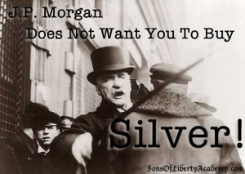In this article, I intend to put forth a plan that will fundamentally change the game and do it from outside the system. It will overthrow the Elitist system that enslaves us with debt and do so without a shot being fired. Most importantly, there is no way the Elite can stop it. The plan is quite simple, sell every single asset you own right now and buy physical silver.
As with anything else in life, knowing the answer, is not as important as knowing the “why.”
The “why” is what brings about fundamental change in your thinking.
This change in thinking brings about absolute certainty of the outcome.
Absolute certainty brings about massive action.
Before I go any further, I want to have my “cover my ass” moment. I am not a financial adviser. (You can see my parody of these CONmen in my video Wall St Laughs at Main St.) I am extremely biased and fully invested in silver. Silver is extremely volatile and not suitable for most investors. Look at what happened in 2008 and just yesterday, it was down 5% in 15 minutes. I will not be held liable for any losses you may incur but I will be glad to take any donations if things do go the way I see it. You need to have food, water, guns, ammo and supplies before you should even consider investing in silver full force. The most important preparation you can make is metal preparation and nothing does that better then the Sons of Liberty Academy. Before you let my highly convincing arguments wash over you, take time to do your own do diligence. Don’t make any rash decisions decisions like selling your house, 401k, stocks, and family business to go out and by as much silver as you can get your hands on, with a seven and a half month pregnant wife. Only a crazy person would do that… Right?
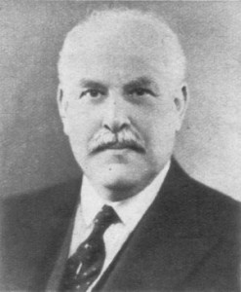“Banking was conceived in iniquity and was born in sin. The bankers own the earth. Take it away from them, but leave them the power to create money, and with the flick of the pen they will create enough deposits to buy it back again. However, take it away from them, and all the great fortunes like mine will disappear and they ought to disappear, for this would be a happier and better world to live in. But, if you wish to remain the slaves of bankers and pay the cost of your own slavery, let them continue to create money.” – Sir Josiah Stamp, Director of the Bank of England (appointed 1928). Reputed to be the 2nd wealthiest man in England at that time.
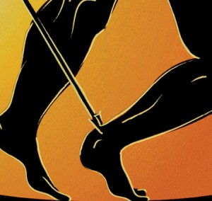Silver is the Achilles Heal of the Elite’s paradigm. By transferring their fake, corrupt paper money into real honest money like silver, it will ultimately destroy of their control of the money/debt. The more money/debt they create, the more it will work against them as we put more of that money into silver. Think of it, every single evil in this world, is only made possible through Elite’s debt/money system. Through the control of the of the privately and foreign owned central banks, the Elite control our money, food, industries, government, media, natural resources, capital markets, military and the ultimately you. It enables wars, propaganda, police state, corruption, pollution, crime, drug trade, disintegration of families, etc. In fact you give me your evil that you fight against, I will show you how it comes back to the very corrupt basis of our money. I intend to show how silver is the antiseptic for all of these ills.
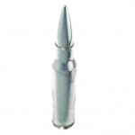Buying physical silver acts both a Silver Bullet to the all of the evils in the world and acts as a Silver Shield for all that you love in this world.
- Buying silver will bring amount more political change than all of the political campaigns will ever do.
- It will reverse the tide of wealth from going to the Elite and even to Asia.
- It will stop tyranny and free billions from the bondage of debt slavery.
- It will bring about a new era of human progress unlike anything we could imagine right now.
If we simply take away the Elite’s power, how fast could we progress as a human race if we did not waste our efforts on debt, wars, and taxes? The Silver Bullet and Silver Shield can and will bring about this change. Now that I have raised the bar to the moon, let’s get this show going.
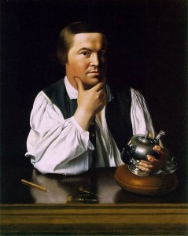Buying physical silver can be the Second American Revolution without firing a single shot. In order for a revolutionary idea to take hold, you must feel it in your soul. It is important to know that everyone is not motivated the same way as others. I will attempt to lay out as many rationals as I can for you to commit to this plan and to encourage others to do the same. I will use both positive and negative motivations on why you should buy silver. I will appeal to your rational and irrational desires. I will give the financial, historic, political, geological, mathematical, legal, intellectual, emotional, and even spiritual reasons on “why” to buy physical silver.
To buy or not to buy silver is the greatest decision you will have to make before the worldwide collapse of the debt based fiat currencies. If you do fully commit to this idea, you will be taking charge of your future and I believe you will create generational wealth. If you do not commit to this plan, I bet your grand children will curse and spit at you for not taking advantage of this greatest opportunity ever. I do have a flair for the dramatic, don’t I
Throughout history, Silver has been used as money in more times in more places than gold.
To function as money, a monetary item should possess a number of features:
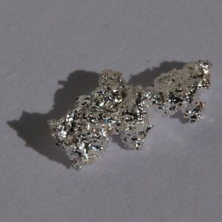To be a medium of exchange:
- It should have liquidity, and be easily trade able.
- It should be easily transportable; precious metals have a high value to weight ratio.
- It should be durable.
To be a unit of account:
- It should be divisible into small units without destroying its value; precious metals can be coined from bars, or melted down into bars again, with a low percentage cost.
- It should be fungible: that is, one unit or piece must be equivalent to another, which is why diamonds, works of art or real estate are not suitable as money.
- It must be a specific weight, or measure, or size to be certifiably countable.
To be a store of value:
- It should be long lasting, durable, it must not be perishable or subject to decay.
- It should have a stable value.
- It should be difficult to counterfeit, and the genuine must be easily recognizable.
Today silver is not used as money since it does not circulate but still provides a crucial role as a store of value.
Why does silver or gold have value? This is a very fundamental question. I think one of the best answers came from a movie call the Treasure of Sierra Madre. An old miner was explaining why gold has value. He said that 1,000 men head for the hills with pick axes and provisions after 6 months only one finds any gold. That find represents not only the labor of the man that finds that gold but that of the other 999 miners that did not find anything. That is 6,000 months or 500 years scrambling over mountains going hungry and thirsty. Think about the luck of finding something so rare. Think about how much energy, labor, ingenuity and time that goes into finding silver or gold. Sometimes it takes moving a couple tons of earth to find one ounce of gold or silver. And here we can buy all of that for less than a dinner for four at your local sports bar.
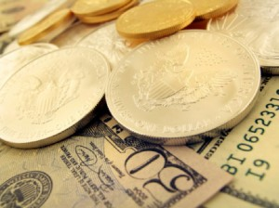Why silver and not gold? 95% of all of the gold that has ever been mined is still in existence in some form or another because it has treasured. 95% (probably more if truth be told) of all of the silver that has ever been mine has been destroyed and used in such small quantities that it is gone forever. The Elite and their Central Banks own tons of gold and NO silver. Silver is cheaper than gold, the average American can buy and ounce of silver without much thought. If they wanted to buy even one ounce of gold they would have to talk to their wife about it. This means that when the chickens come home to roost, more people will be able to afford silver on the way up than gold. Gold has very little uses compared to silver. Gold mines are common but silver is mined mainly as a by product of zinc.
The Gold Anti Trust Action Committee has led the charge for years in exposing the bankers manipulation of gold. Their investigations and awareness campaigns have lead to a heightened awareness in the investment community. GATA is headed by Chris Powell and Bill Murphy and they spent $265,000 to get a full page article in the in the Wall Street Journal asking “Where is our Gold?” This brave action ask the investment community why our Gold reserves have not been audited in 50 years and where is it. If you are like me, I judge men not by the answers they give but by the answers they ask. This question was a direct assault at the heart of the beast. GATA found out that awareness campaigns are nice but they do not change the game. I remember year or so after that, Bill Murphy and GATA had a campaign to actually sell gold and buy silver because the battle against the bankers was much easier to win in the silver market. No central banks have silver sell like they do gold. The market for silver was so small compared to gold that very little money would be needed to have the bankers capitulate in their duplicitous acts. When the Gold Anti Trust Action Committee says sell gold and buy silver, you have to pay attention.
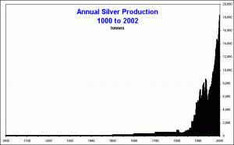Silver has been used as an industrial metal for the past hundred years and not been cherished for what it really is, a precious metal. Industrial metals are metals like aluminum, copper and iron are plentiful and can be used in huge quantities and can be disposed of or recycled. Unlike most industrial metals, silver is used in such small quantities, in proportion to the finished product, that it is not recycled except in photography. Silver has literally been thrown away into toxic trash piles all over the world and thus disappearing. In fact there here is an article showing that for 64 years the world consumed more silver than it produced.
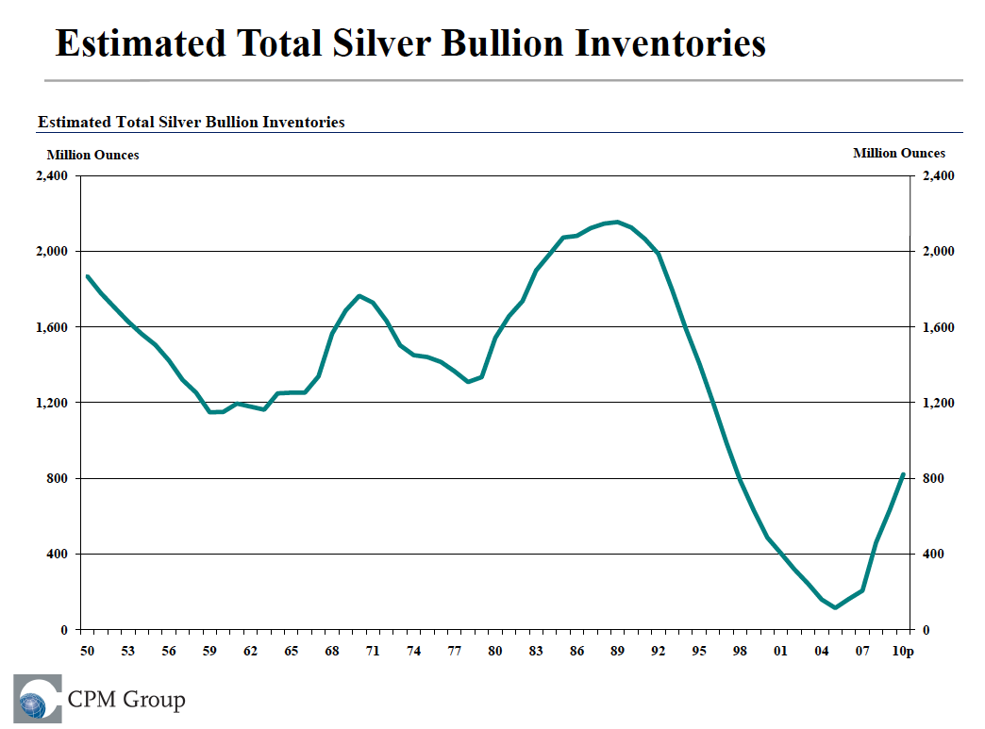Silver is the indispensable metal, next to oil silver is the most widely used commodity ever with over 10,000 uses. As the world technological progress expands, it uses will explode even further. It’s unique characteristics are unlike any other commodity in the world.
- Most Reflective of all Metals
- Greatest conductor of both Heat and Electricity
- Strongly Resists Corrosion and Oxidation
- Second most Malleable and Ductile Metal (Next to Gold)
- Recently Discovered to be a Very Effective Anti-Microbial/Bacterial
It is used in…
- Batteries
- Bearings
- Brazing and Soldering
- Catalysts
- Clothing (My new dryer uses silver to clean clothes better with less water and energy.)
- Coins (Wait until you see the demand skyrocket when the rest of the world wakes up from their Fiat dream)
- Electrical
- Electronics (Cell Phones, Computers, TVs, etc.)
- Electroplating
- Photography
- Medical Applications (Hospitals have extensive uses of silver for it’s Anti-Microbial/Bacterial qualities)
- Jewelry and Silverware
- Mirrors and Coatings
- Solar Energy (Peak Oil will raise demand for silver until we get Peak Silver)
- Water Purification (Clean water is the most basic need for human life and yet clean water is becoming more rare.)
Silver is used in such small quantities and it’s unique characteristics make it irreplaceable, this makes its price inelastic. All commodities have a self correcting pricing mechanism, except silver. If a commodities price rises too high demand drops off as people seek substitutes or supply rises to meet the demand and thus lowering the price. This does not exist with silver. Silver is used in such small quantities in high tech components and there is NO SUBSTITUTE for it. The manufacturer or customer will absorb the price increase. Silver is now starting to be used in clothing to reduce smells caused by bacteria. What is remarkable about this is that by weight silver only represents 1/40,000th of total inputs. When used in such little quantities price is irrelevant. With over 20 million tons of polyester sports wear produced every year it consumes 1,200 tons of silver or 38 million ounces. Let’s say for example that the average computer has a 1/10th of an ounce of silver in it. (I cannot find how much is actually in a computer, Google fail.) This means that there is $3 dollars of silver in the $2,000 computer. If/when silver goes to $1,000 an ounce now that same amount of silver will be $100. Do you think Apple computer is going to throw its arms in the air and cry that they have to not sell computers because silver is too expensive? No, they will raise the price of the computer and probably advertise that it has the most silver in it. Do you think the average consumer is going to to say, “I would buy a computer at $2,000 but at $2,100 no way?!” No, they will find a way to get that $100 so they can the latest Miley Cyrus news.
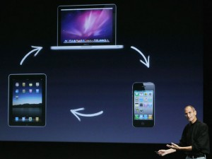It is not just the product that are at risk, it is the companies, industries, and nations that are at risk. Apple has a market cap of $300 billion dollars and if a strategic commodity like silver starts having shortages their billion dollar empire is endangered. Companies like Apple will go into panic buying securing any amount of physical silver they can because their entire value added business is dependent on it. They will not buy SLV or certificates of deposit, only the real silver thing. They will whip out their huge check book and stock up. Now you can see why rising prices will actually increase demand. It is not just the Computer industry that is relying on silver, it is the multi billion dollar industries like Energy, Medical, the Military and soon the entire Banking industry. (When their money/debt system collapses.) This directly effects national destinies. Governments held approximately 10B oz of silver in 1950 and have been supplying that physical stock steadily into the market. Today there is no more of that surplus silver left to sell. The nations that manages their resources the best, will win the future.
Unlike industrial demand, monetary demand has no limits. The monetary demand for silver is what will eventually send silver to the moon. Quadrillions of fake money into less than a billion ounces… You can never have too much money, right?
“Paper is poverty…it is the ghost of money, and not money itself.” -Thomas Jefferson
I have seen bright and intelligent men that fail to understand that the electronic digits on their computer screens are not real money. It never fails them though, when they hold and ounce of gold or a 100 ounce bar of silver. That is the sick thing with our society, that we have become so detached from real money and the real world that we cannot even dream of it. Do yourself a favor this week and go to your local coin shop and just touch and ounce of gold or a big fat bar of shiny silver. Then look at the wad of paper in you wallet or worse digits on your bank statement and tell me honestly where you would rather invest your future in.
Infinite money in a finite world. The Irresistible Force Paradox states “What happens when an irresistible force meets an immovable object?” Our debt based monetary system must create more debt every year in excess of the debt AND interest of the year before. ( Read The Contrived Drama of the Debt Ceiling.) This coupled with the fact that the more debt/money the bankers create, the more profit for they have. The more money/debt the politicians spend, the more power they have. This sick symbiotic relationship of the “Lender of Last Resort” meets the “Spender of Last Resort” ensures and exponential growth of money. The Elite will keep using the power of the printing press to maintain their power, but will only accelerate their demise. There is a mathematically inevitable end to this system, as infinite money/debt meets the world’s finite resources and ultimately the limits of human faith.
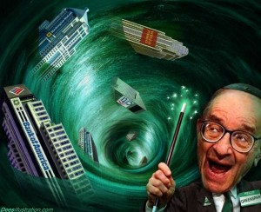The more money/debt chasing after fewer goods and services is what causes inflation. Ultimately, people’s faith in the currency will fail world wide. It will become evident that the Elite intend to print the currency into oblivion, ruining the main function of money as a store of value. When this happens people will literally throw their depreciating currency at any tangible asset they can get their hands on. Precious metals will be the main beneficiary of this because of their unique properties, such as they do not deteriorate, and universally accepted. The frightening thing is that it is not just American citizens, it this will be the first time in human history where the entire world is so interconnected and all on the same basic fiat monetary illusion. Stop thinking of another Great Depression and start thinking another Dark Ages. My suggestion, beat the rush and panic now!!
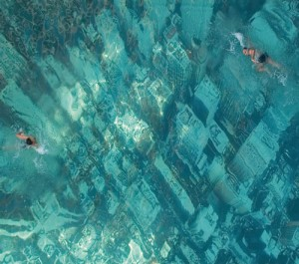Over Population, Unfunded Liabilities, Global Warming and Peak Oil have gotten a lot of attention over the last couple of years. They are Elitist scary campfire stories used to scare the masses into larger global governance. One key flaw in all of these theories is that they all rely on our current monetary order remaining in place. Man has since the time of the Tower of Babel built systems that went against our natural world. This has created great feats, but like most man made systems they are built with the focus of pushing to the extremes and not focusing on a balance. Inevitably things that go up must come down and our monetary system is no different. With the collapse of the monetary order all of these theories/problems will cease to be issues because they will be self corrected by the end of the one thing that makes them possible, exponential growth of money/debt.
When this current monetary order dies so will millions if not billions of people, as the era of unlimited money comes to an end. Think of the millions on food stamps that will have no support system to carry them. Think of the billions in food subsidies ending, food riots and the rocketing food and fuel prices globally. In this hyper-inflationary collapse of the world’s money that I predict, up to 90% of your money will go to food and fuel. Not your mortgage, car payments, taxes, tuition, medical bills… just basic necessities like food and fuel. Most will not be able to make the transition and unfortunately will die. And that is before the wars, riots, and violence take even more people down. This dramatic shift in life will also prevent people from having children in this turbulence. There will be a scar in the human experience that will be felt for generations.
This hyper-inflationary depression will stop global manufacturing in it’s tracks. If you are one of those misguided people that believe in man made global warming, don’t worry your little mind, the collapse of the dollar will do more to stop human activity than ten Kyoto Protocols or Carbon Ponzi Schemes.
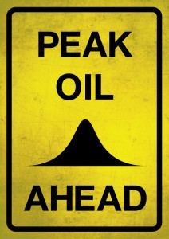Peak Oil theorists you can stop worrying too. When the collapse of the Dollar happens, the energy intensive Western lifestyle will be cut by 75%. No longer will the economy be able to support gas guzzlers, the largest military power ever known or wasteful corporate giants. The value of oil will sky rocket and the demand will drop significantly, leading to a much longer availability of our current reserves. My greatest hope is that the Elite will lose their power to manipulate the all important oil market. I have no proof, but after studying these criminals for 6 years, I believe they have suppressed technology that would have rendered oil less important. I also believe that they have domestic resources here at home that they have not tapped as they set out to strategically use the rest of the world’s oil first. My prediction is that after a new monetary order is established, the Elite will announce “amazing new discoveries” here at home that will shock the world. This will also push that Hubbert’s bell curve out further.
Things that cannot go on forever, won’t. When the mathematically inevitable collapse of the world fiat currencies, all of those problems/theories will no longer matter. There will be massive inflation in real assets with precious metals, food and fuel far outpacing all other assets. This will lead to to a final exhaustion as the old powers try to hold on to power. This will bring about regional wars, civil wars, revolutions, famine, and disease. These events will cut populations, economies, debts, energy use, and our lives back into a much more local and slower reality.
“If you don’t hold it, you do not own it.” -Ponce
Silver has another awesome quality, it has allodial title to it. If you hold it, you own it. Almost everything else you own is controlled by some extent by someone else. If you own your house out right you still have to pay property taxes, which means you don’t really own it. Your cars, computers, TV’s and clothes are rendered less valuable with each registration, taxation, new fashion or planned obsolescence. Even your stocks are not really yours because the actual certificates are held the nefarious DTCC. Who knows if they are selling stock that they do not have. Ever heard of naked short selling?
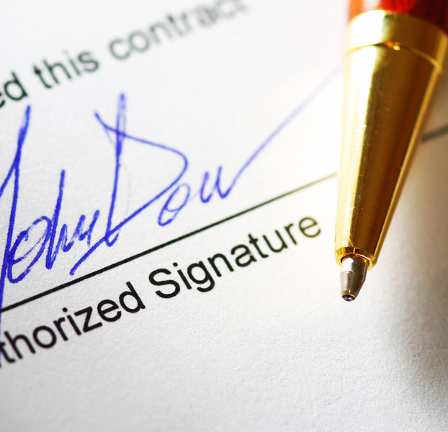Silver is without counter party risk. You do not have to rely on somebody fulfilling a promise for your asset to have worth. All paper assets have counter party risk, they use interest rates to value the risk that you might not get your money back. This will become very important as our society collapses and promises are broken by all. When the collapse accelerates, people will do the unspeakable as they become more and more desperate. People whom you have relied on for years will suddenly break faith. This will happen not only with individuals but corporations and governments. Pensions will be cut, benefits terminated and interest payments not paid. This is where things will get really scary. At this point we will either see a deflationary crash or a hyper-inflationary depression. It will be deflationary if there is not enough money to pay the increasing debt and interest. I believe that the Elite will pay all of the obligations to keep their game going. This will lead you to get every promise paid with toilet paper. Ben Bernanke was asked if the government could afford to pay all of the unfunded liabilities of the US government. He responded that while it was possible to pay all of the liabilities it was impossible to guarantee the purchasing power of those dollars. $100 toilet paper coming right up.
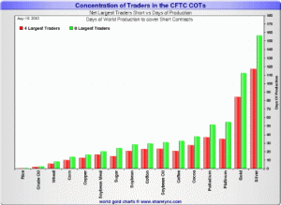“Mad” Max Keiser started a campaign a few months ago called CRASH JP MORGAN BUY SILVER. He is a former banker that provides some of the most cutting commentary on how Banksters really work. This campaign of awareness caught the attention of more than a few people. The campaign is to bring attention to JP Morgan and HSBC’s huge short position on silver. This short position is the largest short position… on anything… EVER. I have heard estimates that for every dollar that silver goes up, these two banks lose $1 Billion dollars. That may seem like a lot of money, but when you understand that the paper price suppression silver and gold is actually one of the pegs of support to the value of world currencies and every other paper asset in the world, losing a billion a day means nothing to support a Quadrillion dollar Ponzi scheme. Silver and gold are actually competing currencies to the Dollar, Euro, Yen, and Yuan. If the Banksters can successfully hold the price of silver and gold down they conversely give support to the paper assets all over the world.
Taking it in the shorts. When an investor shorts something they are literally selling something that they do not have. They promise to buy the underlying asset at the end of the contract. But what if they never buy and keep selling stuff they do not have? It acts as a artificial downward pressure on the price of the asset. This is very common with stocks and can be easily papered over since most stocks are never held in physical form. Commodities on the other hand are the real assets from the earth and have tangible qualities to it. These banks have shorted or sold into the market the equivalent of a six months of total world production. Think about that if these banks were forced to cover it would take either all of the silver miners 6 months to work solely on filling that gap while the rest of the world goes without this vital metal. The most likely thing that is going to happen is that if they are forced to cover the price suppressors become price rocket boosters when they are force to go out into the open market and buy to cover their short.
Harvey Organ exposed this most recent commentary.
“The huge rise in silver price has caught the silver bankers totally offside on the silver banking. The BIS data released in November (www.goldexsextant.com) shows that the G 10 bankers have collectively sold forwards and swaps to the tune of 4 billion oz and short naked calls for another 3 billion oz. The total, 7 billion oz represents 10 years of production. If you just do the forwards, then it is 7 years of annual silver production.
Let us say the average cost of acquiring these derivatives and forwards equate to $15.00 for silver. Thus collectively the entire G10 bankers are feeling massive pain (losses) to the tune of: 7 billion oz of silver( 32.30-15.00) = 7 billion x $17.30 = 121.1 billion dollars of losses.This is in a market of only 14 billion dollars. It begs the question to what economic need was this done.This is still off balance sheet.
If you include only the forwards or swaps (the lending of actual metal to which nothing has come back yet) then the losses are: 4 billion x 17.30 or 69 billion dollars. Regardless how you look at it, the bankers are in serious trouble with this huge rise in silver prices. I hope you understand the severity of the situation.”
“A billion here and a billion there pretty soon you are actually talking about some real money.”
This game has a fatal flaw. The real problem for JP Morgan and HSBC is that there is not enough physical silver in the world to cover their short position. These guys are too sharp and too connected to get caught by this trap and I believe they will set up Enron like hedge funds in the Caribbean to move their positions into these shell companies. And they may even go long and ride the rocket up with us. Until the day comes when they cannot deliver the real physical silver this game will go on. Quadrillions of money in Forex, Debt, Derivatives, Real Estate, Stocks and Bonds are on the line. Not to mention the military, political, industrial, and economic power that is tied to all of that. They will take all of the paper loses necessary to keep this game going. Don’t get upset about this, they are creating a MASSIVE subsidy for you to buy more and more physical silver.
This squeeze is will first show in backwardation. Commodities naturally trade in Contango, meaning that the price is cheaper today than it is to buy in the future. This happens because there is interest, storage, and even uncertainty. Backwardation is simply, it is more expensive to get the commodity now than it is to get it in the future. This happens when investors fear a commodity is going to be hard to get in the future they will pay a premium to get it now. Silver just went into backwardation last week. This is just the first rumble of a much larger earthquake. This has not happened since 1997 when Warren Buffet bought 130 million ounces of physical silver.
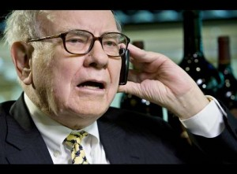Speaking of Warren Buffet and his big silver purchase, why did the ultimate value investor get into silver in such a big way? The bigger question is why the ultimate “buy and hold” investor got scared out of his position. He bought 130 million ounces or 1/5 of the world’s inventory at the time in 1997 and he held that position all the way until 2006. Coincidentally that is the exact same time that Barclay’s started the SLV ETF with 130 million. The only comment I ever found disclosing what happened with this billion dollar trade was Buffet saying, “I bought it very early, I sold it very early. Other than that it was perfect.”
What I am about to say I have no proof of, but I feel would make a lot of sense. Warren Buffet was heavily involved in the AIG scandal with Hank Greenberg. Buffet’s General Re took the other side of a lot of shady AIG’s positions. The deals ended Hank Greenberg in 2005 and yet Buffet escaped with a $50 million slap on the wrist? This was all before AIG stole $186 Billion dollars in the big bankster bailout. Is it out of the realm of possibility to say that Buffet was feeling the heat and offered the Elitist insiders his stash of silver to get out of the kitchen? The timing and situation is way too coincidental.
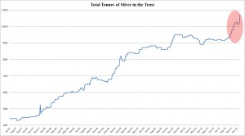Friends don’t let friends buy SLV. I have to admit I was so excited when SLV came out onto the market in 2006. I loved the idea of buying physical silver with the ease of buying a stock. It did not take long for the rumors to come out that there was not enough physical backing of real silver and that JP Morgan and HSBC was the custodians of the silver, I knew this was a scam to siphon off investment demand out of the physical metal into another paper Ponzi scheme. SLV in a few short years has increased its “reserves” 16 x the original stock at it’s inception. When I see that SLV can add 523 tonnes in one week and the price of silver did not go to $1,000 overnight, it confirmed my suspicions.
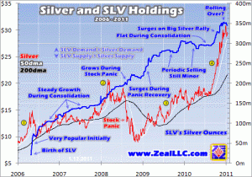Silver delays are well known through out the investment community. Jim Puplava from FinancialSense.com talked about him purchasing 1 ton of silver or 32,000 oz and it took him 3 months to get it filled and delivered. So let’s think about this, an individual demanding 1 ton of physical silver took 12 weeks to fill, but SLV can “take delivery” of 523 tons in one week, give me a break! Recently even the huge supplier the Perth Mint announced a 6 week delay in 100 oz bullion bars of silver. These are not small coins, this is a 7 pound slab of silver that can be produced really quickly. The even larger US Mint had a record month last month with over 4.5 million ounces of silver sold in January eclipsing a record of 4.25 million ounces that was set only two months before that. While that may seem like a lot, it is only $135 million in sales for a month, Apple lost $10 Billion in 15 minutes.
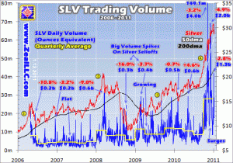Eric Sprott is another pioneer investor that just started the $575 million Sprott Physical Silver Trust in November of last year as he believes that: “Silver will be the investment of the decade.” This fund by itself could force the hand of the Elite. I do not think he will be successful because he has too much to lose and when the Economic Hitmen come a knocking, I am sure he will back down. Poor Matt Simmons… One thing I will strongly disagree with is all of these fund mangers telling the dream of silver and selling them silver mining stocks. DO NOT INVEST IN ANY PAPER ASSET INCLUDING THE VERY ATTRACTIVE SILVER STOCKS.
Andrew Maguire the whistle blower. He was a former silver trader in London who contacted the CFTC last year about insider knowledge on how JP Morgan manipulates the silver market. He informed the CFTC in advance of the silver smackdowns led by JP Morgan. These coordinated attacks lead to huge profits for the insiders, lowers the price of silver, and wipes out bullish investors. After being blown off by the CFTC, he contacted GATA and they published the news to the world. When he turned whistle blower a few days later he and his wife were involved in a serious hit and run in which the attacking driver sped away and nearly ran over more people who tried to stop him from getting away. Police helicopters were called in and captured the driver but no details were released to the public. Andrew Maguire was slated to be on a bunch of news shows detailing his story but all of them except for one (listen here.) canceled on him after the “accident”. King World News who ran the interview was cyber attacked the day after the interview.
I predicted that Silver would go to $50 an ounce by the end of March in my article 2011: Doom is Always 6 Months Away. Pretty bold to predict a 62% increase in 3 months after a 74% increase in the 6 months before that. This was based on a CRIMEX default in the delivery month of March. I think we are getting close to the end of the line for paper manipulation of the physical market. The US mint is having record sales of silver, big money players like Eric Sprott and the richest man in the world Carlos Slim Helu are sniffing the silver market, and the Fed is going to be under pressure to print even more money. But my predictions are small compared to these guys…
“There is very little silver and we need it for everything.” Stephen Leeb on his $100 an ounce prediction.
How about this video predicting $936 silver. Adrian Douglas of Gata predicts this because there is 45 to 100 times the amount of paper silver and gold to the real metal. They do this to artificially support the value of the dollar. When this ends, it will explode the value of the real silver and gold. Adrian sums it up that investments in precious metals is not “about preserving your wealth but multiplying your wealth.”
Mike Maloney predicts $1,500 silver in this video. Bix Weir from GATA predicts $6,000 silver. Ultimately all of these predictions are really ridiculous because it is based on the fundamental lie that the dollar is going to be in existence.
My most shocking prediction is that silver may go to $50 and then you will not be able to buy silver at any price! The reason for this prediction is that this is all about illusion and once that illusion is broken no one will trade their REAL money for FAKE money. This is where ratio investing comes into play.
“Assets are neither really created or destroyed. They merely shift from on perceived value to another.” -Chris Duane
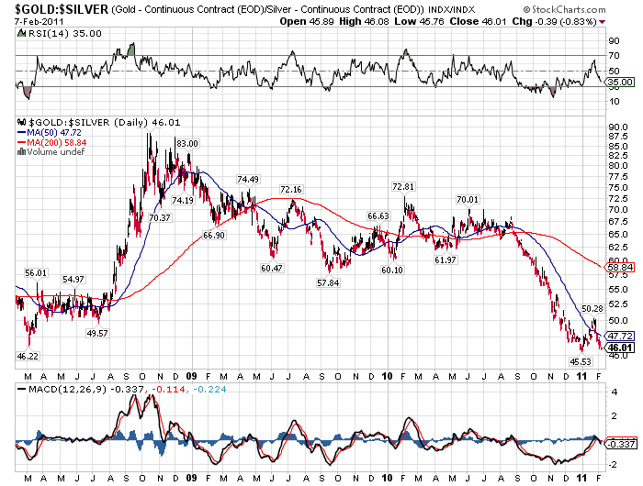Ratio investing. The purpose of this exercise is to see that all assets right now is based off of an illusion of wealth, debt and the dollar. Even the value of real assets like property and companies are tied to this illusion. What is your house worth if there was no 30 year mortgage? This paradigm is going to mathematically end. The infinite growth/debt model with collide with a very finite world. As the pillars of this illusion start to collapse, more and more people will shift their wealth out of paper promises into tangible assets. And since gold has a market cap that is nearly 200 times higher than silver and trades at 45 ounces of silver to one ounce of gold, the potential upside of silver is unlike any other investment opportunity out there. Another was to look at the value of the price of silver relative to gold, is that silver is only 2% of the value of gold. Eric Sprott says that that there is $6 Trillion in investable gold and only $30 Billion in investable silver.
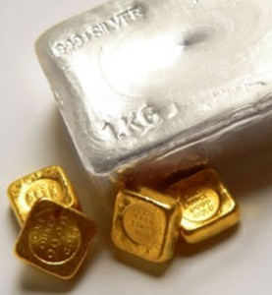Gold ans Silver Ratio.
- Right now it takes 42 ounces of silver to buy 1 oz. of Gold. (42 to 1)
- 700,000,000 ounces of silver was mined in 2009 versus 80,000,000 ounces of gold which is about a 9 to 1 ratio.
- There was an estimated 40,000,000,000 ounces ever mined of silver and an estimate 5,300,000,000 ounces of gold was mined. That ratio is 7.5 to 1 ratio.
Silver has been consumed as an industrial metal, where as gold has been cherished as a precious metal forever. As a result there is still about 5 billion ounces of gold in the world. Silver inventories, on the other hand, have been decimated with only and estimated 5 billion ounces above ground. The other 39 billion ounces are in the landfills of the world in tiny amounts. Maybe if the price of silver rises significantly enough, we will see massive recovery efforts in Staten Island.
•Historically the Ratio has been 16/1 to 10/1. 4x undervalued.
•If the total amount of Gold and Silver above ground is equal to 5 billion ounces that it would put the ratio at 1/1. 42x undervalued.
•Total amount of physical Gold and Silver in monetary/bullion form would put the ratio at 1/5. 230x undervalued. (So Silver to Gold ratio is 1 to 5, yes there is less silver bullion than there is gold.)
So if the price of Gold never went up and based off of Silver market fundamentals it should find some market balance. At that point you could in the extreme case trade your 42 ounces of silver for 210 ounces of gold! (1/5 silver to gold ratio.)
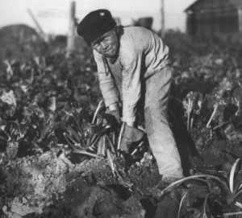Historically, silver been seen as the poor man’s gold and it was the money of the common man. Silver was not as rare as gold, and plentiful enough to be used to pay for basic necessities such as bread and milk. I think in this paradigm of multi-million dollar basketball contacts and no sense of economic reality, it is good to use something I find useful like historical ratios for determining value. For example an average Roman soldier was paid one Denarius for each day of service. Each Denarius was 1/10th of an ounce or about $2.70 a day which is equivalent to the world’s average daily pay. That valuation lasted for hundreds of years for basic labor. So now when you hear, “brother can you spare a (silver)dime?” you know know that it meant a day’s wages. Later, skilled craftsman pushed that wage to almost and ounce a day. Our Constitution actually defines a real “dollar” is a coin containing 371.25 grains (troy) of fine silver or .77 ounce of silver. My hero, Henry Ford pushed that wage to an unbelievable $5 a day or 3.6 ounces a day which was seen as excessive at the time. Today an average worker makes let’s say $100 a day. If there was some economic reality in the system, like real money, a 1/10th of an ounce would equal a days wages of $100. Therefore an ounce of silver should be about $1,000 an ounce, a far cry from today’s price of $27. ( The longer I write this article the more it goes up, now at $33…)
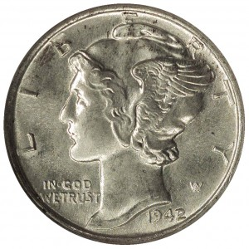A day’s wage was about a dime or a 1/1oth of an ounce for 2,000 years and currently for about 4 billion people. You could buy about 16 years of hard manual labor for about $10,000 with a bag 5,000 of 90% silver dimes. I know college kids with $10,000 dollars available with their credit cards. If they were smart, they would blow their money on a bag of silver instead of beer, pizza and spring break. For $200,000, parents could buy 320 years of hard manual labor in silver dimes or you could send your kid to college to get drunk and find themselves…
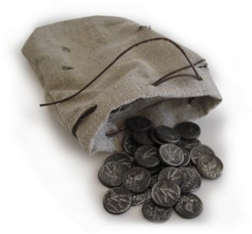Some other historical reference points include Jesus being sold out by Judas Iscariot for 30 Shekles or 15 ounces of silver. Can you imagine selling out your friend, much less Jesus Christ, for $400 bucks? What if we had $1,000 ounce silver? For $15,000, there are a lot of people who would do the deed. (Isn’t that the price hit men charge in movies?) It is also interesting to note that was the same value for a slave at the time. Plots of land were bought in the bible anywhere from 50 ounces to 200 ounces of silver. Good luck finding average properties for $1,250 to $5,000 a piece. But again, what if silver was $1,000 an ounce? Finding properties from $50,000 to $200,000 is a snap. So the purpose of this exercise is to see the ratio between a known silver amount and a known asset. When you take away the manipulated measuring stick of the dollar, the only way to compare an assets value is to compare assets to other assets. So right now it may cost you 2,000 to 8,000 ounces of silver to buy a plot of land. If we have a reversion to the mean, and our debt/money system collapses, you should be able to pick up land for 50 to 200 ounces. I really think that this is even too high, so lets keep digging with this theme.
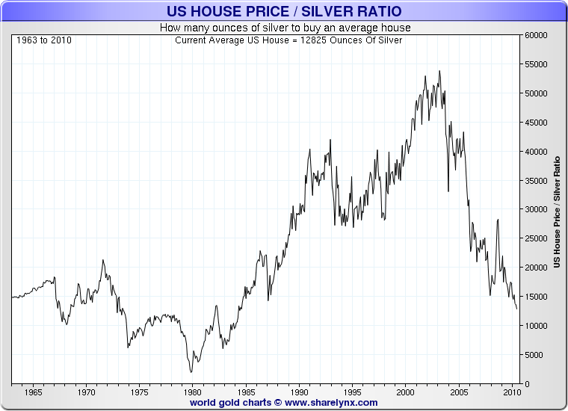There are 36 billion acres of land in the world of which 8 billion acres are arable. So the ratio of silver to total land is 1 ounce of silver to 45 acres of land and 1 ounce of silver per every 10 arable acres. Now I am in Ohio and an acre of arable land here goes from $10,000 to say $40,000 an acre. This would give a dramatically higher implied value of silver.
What I am about to tell you was my prime motivator to bet the house on silver, literally. When Silver peaked in 1980 you could buy the average house for about 800 ounces of silver. This was the days of 20% mortgages and the inflation “slayer” Paul Volker. If you got out of housing at the top of the recent housing bubble you could have traded out of your inflated house value and into the undervalued silver and took delivery of say 40,000 ounces of silver. If/when we get back to the silver house ratio of 1980 you will be able to buy 50 houses for your 40,000 ounces. My advanced strategy that I will be using will result in no taxation on the gains and be able to create 10 times the wealth in this scenario. I explain it in my Sons of Liberty Academy.
I believe that we will shoot way past the previous 1980 peak in the house/silver ratio because there is so much less silver, so much more money, and because of the housing boom, millions of more homes. In fact in Arizona right now I can pick up a 2,000 sq ft home for $40,000 or 1,290 ounces. Could it go to 100 ounces? Who knows? I am confident that this will blow much farther in the extreme. Silver has much more up side and the housing market is nowhere near the bottom.
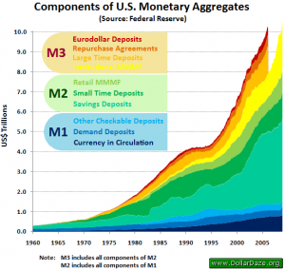At the peak of the Hunt Brothers gambit silver climbed to $48 an ounce. Using the government’s numbers for adjusting for inflation that would equal $128 an ounce. Or conversely today’s price of $31 dollars an ounce is equal to $11 an ounce in 1980. These numbers are very flawed and benefit the government as they have shown to lower inflation. (Read And Now For My Next Trick… No Inflation.) The official inflation implies that the money supply has risen 200% in the past 30 years. Every chart I see shows the money supply to have grow everywhere from 8 to 10 times not 2 times.
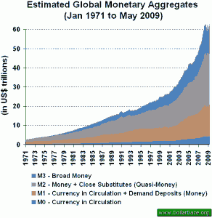In 1980 the entire GDP of the country was $2.5 Trillion dollars and the Federal Budget $590 Billion dollars. Today the GDP is $14.5 Trillion and the Federal budget is actually larger than the entire GDP of the US in 1980 at $3.5 Trillion dollars. $1.5 Trillion of that is pure debt. Do you hear the printing presses whirring? Or more accurately the key strokes on Bernanke’s iMac. The Fed probably has a iPhone app to create billions of dollars on the go…
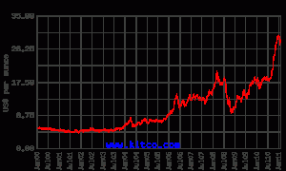Silver has returned 25% annually since 2002 for nearly a 600% return. This is amazing in light of almost every other assets class getting destroyed.
There are 6.5 Billion people in the world and about a 800 million ounces of silver bullion currently above ground. That is .12 ounces of silver per person if every ounce was evenly distributed around the world. But we know that it is not evenly distributed. Think about you local millionaire could easily buy a ton of silver. Based off of that, only 25,000 people in the word could ever own exactly 1 ton of silver. Yet there are 10 million millionaires in the world.
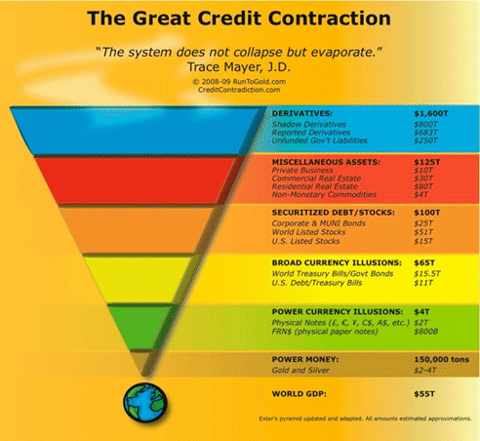Quadrillions in to a billion. Another way of looking at silver is by it’s market capitalization. If there is a billion ounces of silver bullion in existence and silver is at $30, the market cap of silver is $30 billion dollars. Let’s look at how silver’s market cap relates to other values.
One gold miner Gold Corp has a market cap of $30 billion. (1 to 1)
Bill Gates is worth $53 billion. (1 to 1.76)
The total market cap of all gold miners is $250 billion. (1 to 8.3)
It is 1/10th of the market cap of Apple computer which stands at $300 billion. (1 to 10)
The total amount of FRN’s in circulation in the world is $800 billion. (1 to 26)
The total amount of other world currencies in circulation is $2 Trillion. ( 1 to 66)
Physical gold’s estimated market cap is $6 Trillion. (1 to 200)
The total market cap of all private businesses is $10 Trillion. (1 to 333)
The total GDP of America is $15 Trillion. (1 to 500)
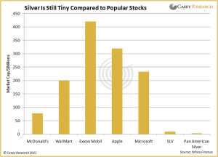The total estimated market cap for all American stocks is $15 Trillion. ( 1 to 500)
The total estimated amount of US Treasuries is $15 Trillion. (1 to 500)
The total estimated amount of world debt is $15 Trillion. (1 to 500)
The total amount of corporate and muni debt is $25 Trillion (1 to 833)
The total value of commercial property is $30 Trillion. (1 to 1,000)
The total estimated market cap of the rest of the world’s stock market is $50 Trillion.(1 to 1,666)
The world GDP is $55 Trillion. (1 to 1,833)
The estimated value of Residential Real Estate is $80 Trillion. (1 to 2,666)
The estimated unfunded Government liabilities is $250 Trillion. (1 to 8,333)
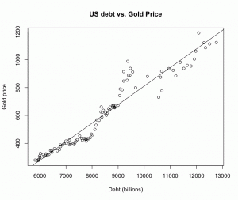The estimated value of Reported derivatives is $700 Trillion. (1 to 23,333)
Finally and estimated $800 Trillion in shadow derivatives in the shadows. (1 to 26,666)
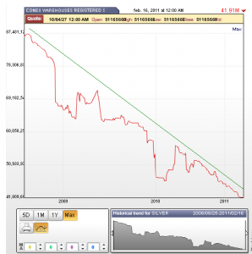The example above takes into account ALL of the silver bullion above the earth’s surface. If we narrow it down to just the available silver in the COMEX/CRIMEX warehouses of 100 million ounces all of those ratios explode by a factor of 10! The United States alone spends more money on interest on the national debt EVERY DAY of $4 Billion dollars than the entire warehouse of available silver valued at about $3 Billion dollars.
Let’s take this even further to really grind it home. Inside the COMEX/CRIMEX warehouses are two classifications of silver, Registered and Eligible. Registered means that there is silver available on demand delivery. Eligible silver can become Registered and deliverable if the owner of the silver wants to sell it. This has a hook of that it cannot be encumbered by obligations like loans taken out against the bullion or if it has been leased out. (That means if you have silver at the warehouses they can “loan” out your silver with a promise to pay it back.)
“If you don’t hold it, you do not own it.”- Ponce
There are only 42 million ounces of silver in the CRIMEX Registered and deliverable category. That is less than $1.5 Billion dollars worth of silver. The world could sneeze and come up with that kind of money. The Elite protect this little hoard with a myriad of tricks but let’s start with the rules. The CRIMEX has a known policy that you can sell unlimited amount of silver (including paper silver that does not exist) but you can only take only a limited amount of silver off of the table. They recently raised the margin requirements by 50% in an effort to shake out weak hands using leverage, and silver went up in response. If things start getting out of control they can force you to settle for the dollar value of the contract. They have even paid in the past premiums to the the contract to dissuade physical delivery.
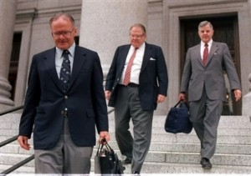The Circle K Boys. If things get really scary for the Elitist banking institutions, they will change and break the rules as they go to drive out any rebels who dare to fight against their control system. All of you have heard of the Hunt brothers trying to “corner” the silver market in the 80′s. Well, take some time and read the REAL story the Elite don’t want you to know. The Rockefeller and Rothschild banking families change the rules, raised national interest rates, margin requirements, and even possibly murdered the King of Saudi Arabia to put a stop to the Hunts attack at the root of the Elite’s power. The long and the short of the whole sad affair DO NOT USE LEVERAGE PLAYING THIS GAME. Pay cash and take physical possession of your silver.
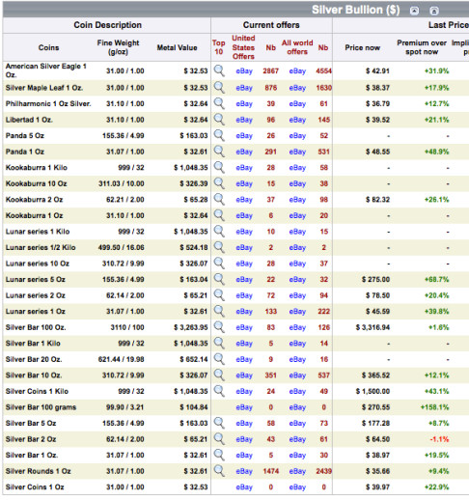While these tricks might work on the big boys, it cannot stop an army of us ants from loading up on all of the silver we want. We can all be mini Hunts and essentially do the same thing by taking delivery. There is a huge disconnect between the paper price of silver printed by the COMEX and the real world price of silver. Check out this awesome site that shows the difference between the CRIMEX price and the EBAY price of silver. The most popular coin of silver in production is the American Silver Eagle and it is going for +31.9% over the CRIMEX price. That does not include shipping and insurance! That is $10 dollars over spot and the premium that these coins got when most these coins were produced was about $1.50, a 666% rise in implied premium. The scary thing is, while things are starting to get warmed up, these premiums will rise as silver becomes more scarce in the market.
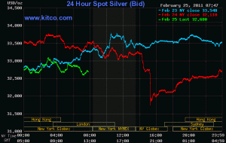The Silver Alliance of ants and big boys are mounting their final assault on the CRIMEX in March 2011. There are over 50,000 contracts that have the potential to take delivery of 250 million ounces of silver in March alone. (Remember there are only 42 Million ounces available.) So just before these contracts came due the Elite raised the margin requirements and then proceeded smack down silver after hours by 5%. This weak attempt will not dissuade enough buyers from standing for delivery in March. The last delivery month in December, silver was up 30% as hedge funds squeezed the CRIMEX. Now that the sharks smell blood, this raid will be much harder and faster. A 30% rise this time would bring silver to $43, but I figured that it will be even more extreme this time around and shoot for $50. I also predict that the $50 price will not just be a blow off top. This time the silver supply shortage will be so apparent, that the illusion is so completely destroyed. People will no longer sell their REAL money for Fake money anymore. If they do, they will want $1,000 an ounce for their silver. Go big or go home.

“The current international currency system is the product of the past,” he said, noting the primacy of the U.S. dollar as a reserve currency and its use in international trade and investment. — Chinese President, Hu Jintao
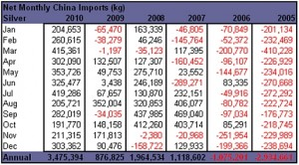China, China, China. China is without a doubt a huge factor in the rise of silver. Once it was the largest exporter of silver, it has swung in 5 years to the complete opposite direction. That is a swing in demand of over 200 million ounces. China has already started to ban exports of some of it’s rarer earth minerals. I have no doubt China will do the same with silver soon enough. China also has the largest holdings of fiat money of our debt and it only makes sense for them to diversify out of the unstable dollar into real assets like silver. The last time China had any significant silver holdings the Western world went to war with China in the Opium Wars. And judging by the recent trial balloons being floated by the likes of Donald Trump we might be going to war with China yet again and this time I think the Chinese will be ready.
Speaking of the Elite screwing countries out of their silver, do some research on the Crime of 1873. The Elitist bankers de-monetized silver after the Civil War that caused nearly 20 years of grinding deflation that benefited the bankers who held the debt. This return to the gold standard was done ahead of the largest silver find of the Comstock Lode that would have freed America from the debts of the bankers. Here are some starter articles, The Crime of 1873 and the Wizard of Oz and On the “Crime of 1873″.
China is also encouraging it’s citizens to buy silver as an investment for the first time in 60 years. Take a look at the State TV unveiling silver as an investment like Ford would show off a new F150. If a billion people by a little of anything, huge swings tend to happen in markets. Also think about how easy it is for the average American to buy 100 ounces of silver while it would seem impossible for the average Chinese citizen to accumulate that. If we are truly headed for world wide flattening of the labor markets as the Elite desire, it is only prudent to stock up on silver as a hedge against that.
The Silver Bears have caused quite a stir recently with their humorous take on the Silver markets. There is even rumors that China is leading the charge in shorting the paper CRIMEX market while they are taking delivery with the physical metal. Once they have taken delivery of all of the physical silver their shell companies can declare bankruptcies and they ride off into the sunset.
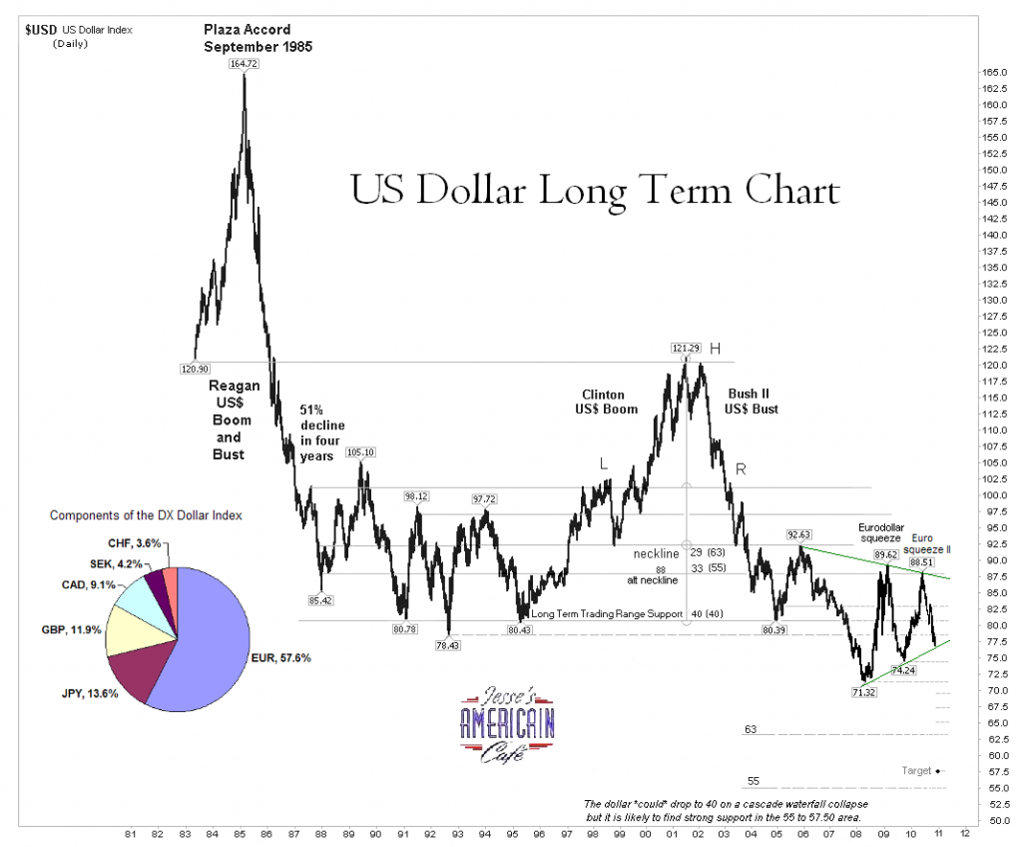Lets get away from all of the silver fundamentals and let’s look at the real reason why we are all buying silver, the Dollar. Let’s face it if the dollar was worth it’s weight in gold, we would not be in this mess. Because the Elite have manipulated the Dollar and the price of silver, historical malinvestments have been made and all of the silver ever mined is close to exhaustion. The dollar is supported by many things, all of which are failing.
- 10 years of war have hurt the military.
- We are losing the monopoly on oil, which is why Iran is in the cross hairs.
- Our industry is decimated.
- Our boarders are wide open bringing in 24 million illegal immigrants into the system.
- The housing and stock bubbles have wiped out the middle class.
- Debt is rising at all levels, exponentially.
- Our government is weak and ineffectual.
- Saudi monarchy is failing.
- 80 million baby boomers are now starting to suck from the giant ponzi scheme.
- Our debt is no longer wanted overseas leading to the “lender of last resort”, the Fed, to create more and more money out of thin air.
It will not take long for all of the supports to get knocked out and it will be a world wide run to the fire exit of gold and silver. There will be no warning and there will be not time to move assets around. The long term chart does not look good and with over 500 other currency collapses, why would the dollar be the exception? Beat the rush and panic early.
“For you know quite well that the day of the Lord’s return will come unexpectedly, like a thief in the night. When people are saying, “Everything is peaceful and secure,” then disaster will fall on them as suddenly as a pregnant woman’s labor pains begin. And there will be no escape. But you aren’t in the dark about these things, dear brothers and sisters, and you won’t be surprised when the day of the Lord comes like a thief. For you are all children of the light and of the day; we don’t belong to darkness and night. So be on your guard, not asleep like the others. Stay alert and be clearheaded.” Thessalonians 5:2-6
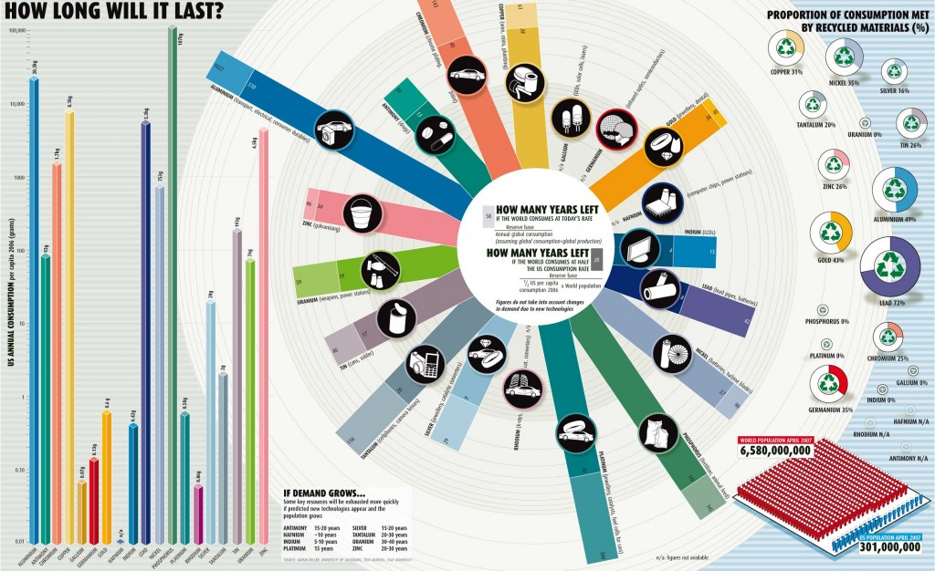I have seen articles by Adrian Douglas from GATA that claim the USGS said silver would be extinct by 2020. I said with all the stuff I know about silver this would be the most incredible exclamation point on why you should sell every single asset you have and buy silver now! Adrian did not cite the source but I knew this guy would not put his reputation on the line for a crazy claim like that, so I sent an email to the USGS myself.
“Adrian Douglas wrote a report that claimed the USGS said that silver was going to be the first element to become extinct and as soon as 2020. Was this written by the USGS and where is it?”
I got back from the USGS was this…
I don’t believe that the USGS would ever use the term “extinct” in regards to the depletion of a resource. The USGS estimates current worldwide silver reserves are estimated to be 510,000 tons. The global demand for silver in 2009 was about 24,400 tons. If nothing else were to change, the implication would be that we’d run out of silver in about 20 years. However, new deposits are still being discovered, and scarcity should lead to higher valuation, which should eventually lead to more exploration interest. Here’s a diagram showing silver’s relative abundance.
While cheap silver ore may become scarce, given the right price, it shouldn’t become extinct!
Regards,
- Greg Durocher
- USGS Office of Communications & Publications
- Science Information Services – Alaska
That last line is what this is all about. The bankers manipulated the price of silver down that gave rise to a quadrillion dollar Ponzi scheme to give them unlimited power and profits. This manipulation has caused incredible malinvestment so that all of humanity has trashed a precious metal to consume it to the point of oblivion. At some point, very soon, the physical market is going take over and all of the games that the bankers are playing will end. It will be game over and you will never see a more dramatic rise in price in anything, ever. Quadrillions in debt/money to less than a billion ounces of honest money silver. When silver’s value is re-established and once again treated as a precious metal, humanity will stop wasting this metal and the higher prices will force wiser use and recycling of silver. Silver will not become extinct, it will just go to the moon!
This is a once in a lifetime opportunity. There is no other example that even comes close to the stage that is set for the silver rocket launch. Silver has massive economic forces pushing it, the declining dollar, and industrial demand. The entire 5,000 year production of the human race is all but used up. The entire world is for the first time blinded by fiat and digital money. If only one of these reasons can true, it would be enough to create generational wealth. All of these together tells me that an average American can with very little effort, raise a king’s ransom of silver. Truly a once in Human History opportunity.
All over the world we see these color revolutions. They are Western Elite’s funding revolution in areas of the world where they seek to dominate. There was the Orange Revolution of the Ukraine, Rose Revolution of Georgia, and the Tulip Revolution in Kyrgyzstan. Now we are seeing the uprisings in the Middle East and a Jasmine Revolution in China. These revolutions used a simple color to signify a feeling real change. I propose that we start the Silver Revolution. Our sole purpose is to strike the root of the Elite’s power, which is their money system. The best part of this is that this system is going to collapse of it’s own cancerous excesses. All we have to do is be the silver straw that breaks the Elite’s back.
In the end, I believe that we need a monetary system that has competition. Gold and silver should circulate along with debt free treasury notes. Usury should be abolished. Those that use the deceitful practice of forgery, I mean Fractional Reserve Banking, should be thrown in jail. This would end the era of gamblers and insiders and allow honest days pay for an honest days work.
If you need a little motivational music for your Silver Revolution, try this on for size. The Silver War Cry.

“Ideas don’t happen on their own, throughout history ideas need patrons.”
I hope that you enjoyed this article and support future efforts by joining and supporting the Sons of Liberty Academy. The Academy is free to all only through the supportive efforts of it’s members. The Academy seeks to provide the intellectual foundation for the next American Revolution by working outside of the system through educational efforts that promote non-violent, non-compliance and leaderless resistance. Please support our mission only by your promotion and financial support can we spread this very important message.

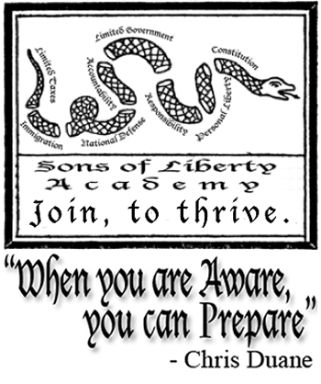
Name
Email

Wake Some People Up!
Economic Collapse Bernanke, Centralized Power, China, De-Centralized Power, dollar, Dollar Collapse, Dollar Crisis, donald trump, Economic Collapse, federal reserve, Fiat Currency, Fiat Money, gold, how to invest in silver, hyper inflation, Leaderless Resistance, Peak Debt, Peak oil, Petro Dollar, physical silver, revolution, rockefeller, Ron paul, Rothschild, silver, silver bullion, silver etf, silver inveesting, slv, Unemployment

My Leap of Faith »

5 comments to The Silver Bullet And The Silver Shield
- Callum
February 25, 2011 at 6:24 pm
This is the best article on silver that I have come across to date. It sums up all of the research that I have personally done myself and is well presented. Well done!
- FunnyMoney
February 25, 2011 at 8:57 pm
Victory will not be measured by what price silver finally reaches but by how many middle class workers have protected themselves with it.
- fiatguy
February 25, 2011 at 9:30 pm
Good article, but I would like to say that don’t put all your trust in silver!
Silver is just for this earth and you can’t take it with you. Having said that, Put your trust in God, your creator. Love is the key, not hoarding silver. One day we will throw the silver in the streets as worthless.
Also, like your house (tax man can take it), you can’t really own silver with no worries either because it is bulky and heavy and if you lose your house I don’t really see how you could lug silver all over the place and not become a target. Unlikely scenario, but I put it out there.
- Twisted Titan
February 26, 2011 at 1:09 am
The Silver Revolution
I really like That tag line
- spdrdr
February 26, 2011 at 6:53 pm
Bravo! A superb, concise summary. I have been scratching my head for over a year reading and trying to understand FOFOA’s FreeGold concept, but this article above does it (from a Silver perspective) in an articulate manner that is innately comprehensible for we poor rubes without Ph.Ds.
The above article, Ladies and Gentlemen, is FreeSilver. FreeSilver will work hand-in-hand with FreeGold, and indeed they will augment each other.
The concept, once the scales fall from your eyes, is beautifully simple.
The world has a whole lot of “stuff”, that has inherent value. This value is a relatively constant concept throughout the ages. If you divided all of the “stuff” in the world by the weight of all the gold and silver in the world, each ounce would be worth an enormous amount of the local currency. The currency could still be used as a means of exchange, but traders and nations would exchange gold and silver to pay for all the “stuff” bought and sold.
Gold and silver would be a store of wealth for those who produce more than they consume. We can indeed follow in the footsteps of Giants:
“While these tricks might work on the big boys, it cannot stop an army of us ants from loading up on all of the silver we want. We can all be mini Hunts and essentially do the same thing by taking delivery.”
Thank you, an awesome article. SPECIAL REPORT: THE END OF OZ
Bix Weir
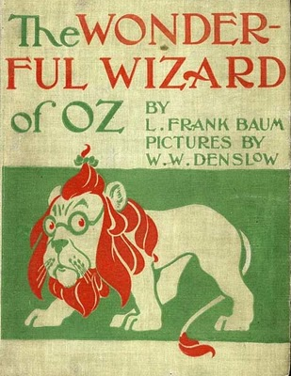
Spring 1964: A little known high school teacher named Henry Littlefield published an article in the American Quarterly arguing that the novel "The Wonderful Wizard of OZ" was a cleverly disguised satire on the politics of the late 1800's America. He also argued that the Author, Frank Baum, devised the first "truly American Fairy Tale" as a Monetary Allegory on the virtues of a bi-metallic monetary system and the fight against the evil bankers.
The Wizard of OZ: Parable on Populism http://www.amphigory.com/oz.htm
Since this article was publish there have been many follow on articles and other theories developed as to the meaning of the story but the monetary symbolism lives on in the hearts of millions of gold bugs and hard-money advocates around the world.
The following is my interpretation of the characters and plot of the original OZ story drawing mostly from the original Littlefield article but also others that have been published.
CHARACTERS
Dorothy = The "Everyman" representing the many "Sheeple" that live their lives from day to day unaware there is more going on behind the scenes. Dorothy wanted to find her way home (to the ideal of the United States of America as set forth by our Founding Fathers)
The Scarecrow = Midwest farmers whose years of hardship and self doubt has made them the subject of ridicule. The Scarecrow was in search of a brain.
The Tin Woodsman = Represented the nations workers and in particular industrial workers who were being disenfranchised by the industrial leaders and banking concerns. The Tin Woodsman was in search of a heart.
The Cowardly Lion = Represented William Jennings Bryan, the Nebraska Congressman who was the Democratic presidential candidate in 1896 and 1900. Jennings was known for his roaring rhetoric but didn't have enough support and confidence to back-up his verbal attacks. The Cowardly Lion was in search of courage.
The Wizard = A manipulative politician or even the President of the United States.
The Wicked Witches = Represent financial-industrial interests and their gold-standard political allies, the main targets of Populist venom.
The Colors of Money = The story is richly bathed in the colors of gold, silver and green all having vital importance to both the plot and the monetary allegory.
THE PLOT
In its most basic form, the plot of The Wonderful Wizard of OZ is a quest by the people of the United States of America to take back the control of their monetary system by "melting" the evil cabal of bankers and industrialist that use and abuse the power of money for their own purposes. It is truly a battle between the forces of good and evil, and, as in most good fairy tales, good will always triumph over evil...but this tale never really ended!
********
At the end of Baum's novel Dorothy returns to the "colorless" world of gray Kansas and loses her silver slippers. Here is an excellent interpretation of the actual results of the adventure:
"Neither the Scarecrow nor the Tin Man nor the Lion truly lacked what each believed he was missing; the great Wizard's powers proved illusory; and Dorothy had the power to transform her condition all along. These features of the story point to a more ambivalent result. Indeed, Populism's outright failure is suggested when Dorothy's silver shoes fall off in the desert and are "lost forever." After Bryan's defeat in 1896, the free-silver movement went into rapid decline. McKinley's reelection and the statutory adoption of the gold standard in 1900 spelled political oblivion for the Populists."
http://www.usagold.com/gildedopinion/oz.html
It's plain to see how our monetary realities have transpired since the story was written over 110 years ago. Today, the total and complete transfer of control of our monetary system has almost been achieved by the banking and industrial powers.
Could it be that for over 110 years this "Truly American Fairy Tale" is still in process? And if so WHEN WILL WE FINALLY MELT THE WITCH? Don't ALL fairy tales really END with the final defeat of the evil villain, or are we going to realize Dorothy's worst nightmare and never return home?
*********
THE END OF OZ
We last left our hero in the Wonderful Wizard of OZ on the plains of Kansas in a gray, dark land with very little hope for introducing the colors of OZ (gold/silver backed monetary system). Since the book was released in 1900 there have been many "remakes" of the OZ story in books, films and plays but they have all ended on that same sour note of Dorothy returning to the colorless world.
Net effect = No change
…until NOW!
In December 2007 the SciFi Channel aired the latest remake of the OZ tale with the release of "Tin Man". This new version of the old tale was complete with the latest special effects and a new angle. It is clearly not based off the original characters in Baum's 1900 era plot.
Here is the original Trailer for Tin Man: http://www.youtube.com/watch?v=gs5PEEzaxjU
You can buy the Collector edition here:
http://www.amazon.com/Tin-Two-Disc-Collectors-Zooey-Deschanel/dp/B0010X744G
Or you can instantly download all three episodes here:
http://www.amazon.com/gp/product/B003VWSX4E/ref=sr_1_1_vod_2_pur_sea?ie=UTF8&s=digital-video&qid=1298612152&sr=1-1
Truthfully, when I first watched this movie I was on the hunt for clues to the Monetary Allegory angle and I didn't see them. It seemed to me to be a very bizarre telling of the story that made no sense at all. Was this just another attempt to suck some more profits from the original tale by updating it with special effects for today's attention-deficit-disorder audience that refuses to watch movies unless they are in 3D on an iMax screen?
So I did a little more checking, a little more thinking and a LOT more opening my mind to the possibility and WHAM! There is was. Clear as day.
A NEW MONETARY ALLEGORY BASED ON TODAY'S EVENTS!
One that is based off the CURRENT EVENTS discussed in:
The Road to Roota Theory http://www.roadtoroota.com/public/190.cfm
Let me walk you through it with the characters and plot like I did above:
CHARACTERS
D.G. = The "Everyday" person represented by the US Congress. The initials D.G. stand for Dorothy Gale from the original story. Just like Dorothy, D.G. is wandering through life with blinders on but also a feeling that something was not right about the world she was living in.
Glitch = The character Glitch is a take-off on the Scarecrow who once had a brain but it was removed by the bad guys and now he is a bumbling fool. Glitch was once the Queens most trusted adviser who invented a digital machine that controls the entire O.Z. (Outer Zone). Glitch represents Alan Greenspan who used his computer programming ability to rig the "free markets" since the early 1970's. This computer control was stolen by the banking cabal in the late 1980's and Greenspan turned into the babbling mouthpiece that ran the fiat monetary system from 1987-2007. In the end Glitch regains his brains and fights to take down the banksters. (See "Greenspan's Golden Secret" http://www.roadtoroota.com/public/101.cfm)
Tin Man = The character Tin Man or Cain is a takeoff on the Tin Woodsman. Cain is a cop who has been locked in a metal bodysuit and forced to watch the murder of his wife over and over. The Tin Man represents ex-Attorney General, Michael Mukasey who presided over the 1993 World Trade Center bombings, Jose Padilla 911 trail and the Larry Silverstein WTC insurance trial. Basically, Mukasey oversaw the evil plots by the banking cabal against America and was helpless to stop them for fear of assassination. Like the movie, he was forced to witness the murder of his love (the Rule of Law). Mukasey was one of Ronald Regan's closest allies and part of a small alliance of people in charge of the Gold Standard Implementation process. His son Marc, who got bankster Bernnie Madoff's accountant to turn states evidence against the banking cabal, is represented in the movie as Cain's son Jeb, the leader of the underground resistance.
RAW = The character "RAW" is a takeoff on the Cowardly Lion who, like William Bryan, is full of strong rhetoric but lacked the courage to fight the bad guys. RAW represents our friend Ron Paul. For years Ron has spoken out against the evils of fiat money and the Federal Reserve System only to be cast aside. The character RAW is found trapped inside a womb, of sorts, which is symbolic of RP's having delivered over 4,000 babies in his professional career as a doctor. RAW is able to see the future just like Ron Paul has seen the destruction of the fiat monetary system. RAW is found trapped in the "fields of the Papay" which have these scary creatures that I believe represent commodity traders on the COMEX.
Tutor = The shape shifting character Tutor is a takeoff on Dorothy's dog Toto. Tutor represents the ex Fed Chairman Paul Volcker who taught the United States how to float currencies without a gold standard. In the movie Tutor is seen as a traitor for working for the banksters as a spy which Volcker did in real life when he worked for the Rothschilds banking family. In the end Tutor helps to take down the evil empire just like Volcker is currently helping to take down the banksters with his Volcker Rule.
Azkadellia = In Tin Man, Azkadellia is actually the sister of D.G. but becomes possessed by an evil witch when she is a child and turns against D.G. (the people). Azkadellia represents the Federal Reserve System which was taken over by the banksters. Azkadellia wears a gold armored dress for much of the movie until the final scene when she has a silver dress on with the green emerald around her neck. Azkadellia and D.G. stand together to melt the wicked witch with a ray of SILVER while the witch fires a ray of GOLD.
The Witch = The Witch represents the Wicked Witch of the West who tries to take control of the entire OZ and plunge it into darkness. The Witch is found in a dark cave when D.G. and Azkadellia are just little girls and the witch possesses Azkadellia when D.G. abandons her. In the end the Witch is melted by a SILVER beam emitted from the joining of D.G. (Congress) and Azkadellia (Federal Reserve). When the witch is melting the she says "I care not for the heavens do my bidding" which is eerily reminiscent of Mayer Rothschild's quote "Give me control of a nation's money and I care not who makes her laws."
The Mystic Man = The Mystic Man represents President Ronald Regan who began the original attack on the banking cabal in 1980 and tried to implement a gold standard before he was silenced. The first attempt on his life by VP Bush Sr. (with the setup of his friend's son John Hinkley Jr. as the pawn) but what worked was his contracting Alzheimer's (which may have been poison induced by the bad guys). The Mystic Man is addicted to Vapors, a drug created by Azkadellia and is ultimately killed by the queen by sucking a silver mist from his mouth.
Queen Lavender-Eyes = The character Lavender Eyes is a new character to the story but is obviously a representation of Liberty as she is the mother of D.G. and locked away on a small island to stand alone in a gray/green dress. The symbolism to the Statue of Liberty is obvious and D.G.'s attempt to free her represents the "good guys" attempt to restore Liberty to the citizens of the United States of America.
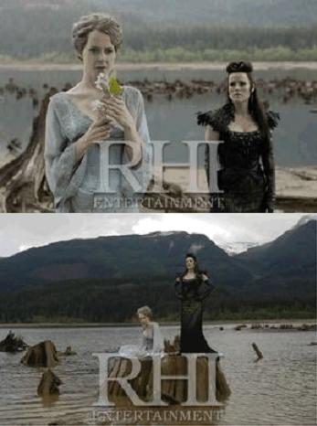
Zero = One of the main bad guy's is named Zero. It is very difficult to determine who the bad guys are but my guess on this one is that it is Dick Cheney. This is only a guess but due to the nasty nature of this character it makes sense that Cheney be represented because he has run much of the banking cabals operations in the US for the last three decades.
Ahamo = The character Ahamo is also a new character to the story and I believe this to be in reference to Warren Buffet the Oracle of Omaha (Ahamo spelled backwards). Although I see no evidence of Warren Buffet working with the good guys today, I believe that he will come through in a meaningful way when the time is right. Here is my take on Mr. Buffett and the taking down of the bad guys (http://www.roadtoroota.com/public/243.cfm)
Mobats = The Mobats are part monkey, part bat creatures who are based on the Flying Monkeys from the original story. They were imprisoned with the Evil Witch of the Dark in her cave and enter into Azkadellia when the Witch takes possession of her. Mobats represent the Banks that are summoned by the Federal Reserve Banks to rig the financial markets.
Longcoats = The Longcoats are Azkadellia's Royal Troops. Stereotypical evil henchmen, they get their names from the long, black coats which they wear. Their appearance and attitude is akin to members of the SS, Hitler's secret police. The Longcoats represent the Cabals henchmen that implement the more diabolical plans of the Bad Guys such as the Kennedy assassination and false flag operations (ie 911 style attacks).
THE PLOT
Although the plot of "Tin Man" holds many of the same monetary concepts as the original story the characters and story line have changed dramatically. DG's always felt that there was something missing in her life...some cosmic meaning. When she is transported to the O.Z. by the tornado (financial crisis) she begins to understand that there is a world that was hidden from her.
In this new world D.G. (Congress or The People) discovers she has a sister (the Federal Reserve) that was once good but turned bad when she became possessed by an evil witch(Banking Cabal). When they were young they worked and played together learning how to make their green doll float (floating fiat currencies) with the help of Tudor (Paul Volcker). She also learned that she had a mother (Liberty) who loved her very much but was locked away on an island by the witch. Her mothers most trusted adviser and once the smartest man on the O.Z. Glitch (Greenspan) invented a digital machine called the Sun Seeder (Greenspan's original gold market rigging computer programs) that the witch stole and was using it to destroy the O.Z.
D.G. relives the moment when her sister becomes possessed by the evil witch and understands that it was her fault her sister became possessed by the evil witch. Upon entering the cave of the witch D.G. became scared and ran from her sister's side breaking their silver, glowing grip that provided protection (silver money controlled by Congress). She soon realizes that all of the tragedies which have befallen the O.Z. are the result of that mistake she made as a child (Congress giving up control of fiat money to the Banking Cabal). D.G. also learns that she has more power than she knows and goes on a journey to find the Emerald of the Eclipse (the power of fiat US Dollars) to stop the evil witch from destroying the O.Z.
D.G. travels through many strange lands on her way to find the Emerald of the Eclipse. First was a forest where the Eastern Resistance (Chinese) were fighting Azkadellia's Longcoats but did not have the size and power to do much damage. Then there was Milltown (any US Manufacturing town) which has been all but destroyed with only some 1/2 human and 1/2 robotic people (technology replacing human production). D.G. travels to a place that looks very similar to the halls of the US Congress with large marble walls and columns to finally find the Emerald but Azkadellia steals it from her. The power over the Emerald (fiat USD) gives her the power to "bring eternal darkness to the O.Z."
D.G. rejoins with her group of new friends (Ron Paul, Michael Mukasey, Alan Greenspan, Paul Volcker) to take back the Emerald of the Eclipse. D.G. confronts Azkadellia as she is using the Emerald and the Sun Seeder to lock the the two suns behind the moon and banish the O.Z. to eternal darkness (Two EMP satellites that may have been the original end game for the banking cabal).
In the end, Azkadellia removes herself from the grasp of the wicked which and standing hand in hand with D.G. attack with a SILVER beam of light as the witch fights back with a smaller GOLD beam of light. The witch melts, the sun comes out and the O.Z. is instantly transformed to it's original state of beauty, abundance and "liberty and justice for all".
The final line in the movie is:
"Now this is the O.Z. I remember".
MORE EVIDENCE
The Producer -- When I first started investigating this movie as a play on current events I had to establish a link between someone who was involved in this movie and the good guys who are taking down the cabal and it didn't take very long. The main driving force behind the production of Tin Man was Robert Halmi Sr. who is not only a very famous movie producer but is also worked for the CIA…. http://movies.yahoo.com/movie/contributor/1800275083/bio
Halmi's early days with the CIA give him the perfect insiders view of the battle between the Good Guys and the Bad Guys. If you watch the interviews with him about the movie (in the special features of the DVD) it is clear that he had a passion for making this film and carrying on the long held traditions of the original book but updating them for today. This includes the monetary allegory angle.
Gold/Silver Role -- Gold and silver play a HUGE role in the entire movie from start to finish. Here are just some observations:
- The "Yellow Brick Road" is missing many gold bricks just as suggested by the GATA crowd that the Gold in Ft. Knox is long gone
- Silver plays a VERY big role with a silver glow showing up when D.G. is feeling lost in the café, the silver glow when D.G. and Azkadellia make their red and green dolls float (floating currencies), when a Silver net that looks a lot like silver ore is dumped on D.G. and friends (COMEX dumping), the doll that glows silver that is given to Ahamo (Buffett), silver drives away the bear (Stearns?) and ultimately it is silver that kills the wicked witch.
- At a pivotal point in the script D.G. goes into a building that looks like marbled Congress to retrieve the Emerald (monetary authority). When she enters the room she is transported into a black and white version of a farm in Kansas where the real Dorothy hands D.G. the emerald. D.G. Looks down and sees Dorothy wearing SILVER slippers! Too symbolic to be accident if you ask me.
- Azkadellia wears gold armored dresses most of the time that she is possessed by the Wicked Witch. In the end she is in a silver dress and is ultimately freed from the witch by the silver beam coming from the joining of Congress (D.G.) and the Federal Reserve (Azkadellia).
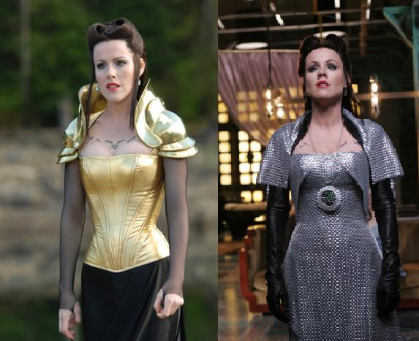
Tin Man Interactive - The ScyFy Channel has set up an interactive website that takes you through the art of the movie in "Enter the Infinite OZ". During the journey you will find it starts with a Golden scene, goes through a scene with a multi-colored road (various commodities), through a cave filled with geologic mineral deposits(secret Grand Canyon deposits?) and ends on a beautiful SILVER ROAD that leads to your destination! It can be found here:
http://www.syfy.com/tinman/oz/
All Seeing Eye = To top off all the monetary symbolism they even include the "All Seeing Eye" that is put into D.G.'s hand. To enter the Congress like building and find the emerald D.G. uses the power of the all seeing eye.
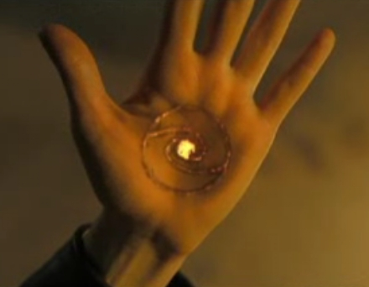
Here are some posted YouTube Videos for those who don't have the DVD of the movie:
http://www.youtube.com/watch?v=_LD7Mvfjv00&feature=related
http://www.youtube.com/watch?v=1B0SN8Sspys
http://www.youtube.com/watch?v=MzzUY2GG0bI
I know this is a lot to take in as it has taken me YEARS to come to these conclusions BUT it is an AMAZING angle at an historic moment in time. You will need to watch this movie, look for all the clues and judge for yourself.
Oh, this report is only PART 1 of my analysis!
PART 2 will address the following themes:
- Red and Green dresses represent FRN's and Treasury Notes
- The Rothschild Shield is on the wall of Azkadellia's castle
- Floating Green doll represents the floating fiat currency system
- The bear represents Bear Sterns
- The digital codes to stop the "Sun Seeder" are significant dates in our monetary history
- Xora, the leader of the Mobats, represents Goldman Sachs
- The hidden language in the cave and our hidden history of an ancient civilization that once lived on earth
AND THERE IS MUCH MORE!
Stay tuned :-)
Bix Weir www.RoadtoRoota.com
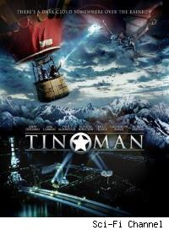
Friday Road Trip 2/25/2010
Bix Weir


Insider Confirmation: Global Collapse Plan Is Locked and Loaded
Lindsey Williams just gave another interview with Alex Jones where he outlines the plans to crash the dollar in less than 2 years. He explains how the US has been hiding oil and will open up these oil fields when the dollar crashes. He also give an excellent description of how the "Oil Backed Dollar" scam was implemented. Here's the interview:
Do you remember this frame in "Wishes & Rainbows" where Roota uses black tears to grow new colored flowers?

Here we have "black tears"(oil) that is used to grow the "colored flowers"(oil backed dollars).
Is it all making sense to you? If not go back to the original Road to Roota:
http://www.roadtoroota.com/public/120.cfm
I would like to point out that Lindsey Williams, as well as I, know that this does not have to turn out as bad as the Bad Guys want it to. We are free human beings no matter how much we feel controlled.
WE CAN STAND UP AND SAY "ON MORE"
AND WE WILL!

The Other Insider's Predictions Coming Fast!
Now is a good time to go back and revisit the 9 points from this article:
Confirmation From The Insider
http://www.roadtoroota.com/members/406.cfm
1) "The Election is crucial to the future of our Republic"
2) "We are on the verge of a revolution"
3) The Revolution can be a good thing
4) The Revolution will happen with a lot of turmoil
5) Expecting a financial collapse
6) Expecting a US Dollar breakdown
7) "Because of our traditions we can come out of this chaos quite well"
8) States and individuals will turn their back on Federal Government
9) Bring back jobs, protect our borders, bring back troops
Every single one of these are on track and you can see developing before your eyes. There is even talk of the government shutting down...
Government Shut Down
http://www.huffingtonpost.com/2011/02/23/government-funding-talks-dissolve_n_827431.html
All the states are going up in smoke as well. This is very important in the process because when the banking system breaks down WE THE PEOPLE will be in "Revolution Mode".

The SEC Cabal Insider "Take Down" Has Begun
The Madoff take down hit at the heart of the Bad Guys and the reverberations will spread throughout the banking cabal very soon. Here we have the head honcho over at the SEC legal department getting busted...AND IT'S ABOUT TIME!
http://finance.yahoo.com/news/Top-SEC-lawyer-named-in-apf-3941491661.html?x=0&sec=topStories&pos=5&asset=&ccode=
Top SEC lawyer named in Madoff Suit
Top SEC lawyer named as defendant in suit filed by trustee recovering money for Madoff victims
On Wednesday February 23, 2011, 1:07 pm EST
NEW YORK (AP) -- The top lawyer at the Securities and Exchange Commission has been named as a defendant in a lawsuit by the trustee who's trying to recover money for victims of Bernard Madoff's Ponzi scheme.
The lawsuit was filed by Irving Picard against David Becker, and claims Becker's family earned more than $1.5 million in phony profits from Madoff's investments.
The story was first reported by the Daily News on its Web site Tuesday night.
Becker and his brothers were named executors of their mother's estate, which included a Madoff account. It says they liquidated the account in 2005, withdrawing $2 million.
Becker tells the New York Post he had "absolutely" no idea Madoff was running a fraud. He says the suit is about his parents' investments, which he had nothing to do with.
Becker is the SEC's general counsel, but returns to the private sector next week.
END
More banksters will fall very soon...watch for the end of March for the "big guns" to come out.

Is Carlos Slim Creating the New Barrick...To Suppress Silver Prices?
The latest hot topic to hit the silver markets (as if we needed another) is the supposed 100M ounces of hedges that have come into the mining sector.
Silver miners start hedging on price falls
http://www.ft.com/cms/s/0/af6a0ca8-386c-11e0-959c-00144feabdc0,s01=1.html#axzz1EjYZMj3v
The majority of this looks like it is coming from a company controlled by the multi zillionaire Carlos Slim...But his moves in silver have been all over the board.
Mexico: Slim to expand Frisco's share in small silver miner
http://www.mineweb.com/mineweb/view/mineweb/en/page36?oid=120813&sn=Detail&pid=36
Is The World's Richest Man, Carlos Slim, Entering The Silver Fray?
http://www.zerohedge.com/article/worlds-richest-man-carlos-slim-entering-silver-fray
Mexico's Minera Frisco Seeks To Acquire More Of Miner Tayahua
http://online.wsj.com/article/BT-CO-20110216-717362.html
In my mind there are three possible nefarious reasons for Mr. Slim throwing down such a large hedge (75M oz).
1) To suppress the price of silver before it took off and crashed the monetary system.
2) To suppress the price of silver so he has a chance to buy up silver mines cheaply.
3) To offer JPM his hedging business so they can claim their 100M oz short is mostly a bonafide hedge on physical silver.
and one more possibility...
4) Perhaps he is trying to establish another Barrick Gold where they continually shorted the price of gold into oblivion all the while scooping up cheep mining companies.
Any way you slice it I agree with Ted Butler...THIS IS A VERY DANGEROUS HEDGE BOOK FOR THIS TIME IN THE SILVER MARKET!
Of course all of the above are illegal but luckily the CFTC is too busy squabbling over their new budget to do any real oversight work!
http://www.marketwatch.com/story/rift-opens-over-budget-at-cftc-2011-02-24

Bernanke Sets Up Fed To Take Blame For Crash
There is no doubt in my mind that the FED is now going to fall on the sword and take the blame for the crash. It was not the original plan but the 2008 crash failed so they went to plan #2. This article and testimony is setting the stage.
Bernanke: Regulators Can Handle 'Too Big To Fail' Banks
http://www.huffingtonpost.com/2011/02/18/regulators-too-bit-to-fail_n_825019.html
It all gets back to that line in the movie "Tin Man" where Cain (AG Mukasey) says to DG (US Congress) "You may not be able to save your sister." The sister, Azkadelia, represents the Federal Reserve. Read this article again if you don't see the connection.
SPECIAL REPORT: The End of OZ http://www.roadtoroota.com/public/305.cfm
The banks runs have begun and will continue until the very last bank has closed...
http://www.zerohedge.com/article/korean-bank-run-spreading-eighth-bank-closes-following-massive-withdrawals
FDIC Prepares for "The Big One"
http://www.nytimes.com/2010/02/24/business/24fdic.html
So goodbye Azkadelia...and good RIDDANCE!

Sprott Says "There Is No More Silver"!
Here are two Youtube videos of Eric Sprott who knows more about the physical demand for silver than all of us put together. Listen to what he has to say about the current silver situation.

A Poetic CFTC Comment on Position Limits
I will leave you this week with a comment I ran across on the CFTC website Position Limit postings.
If this doesn't get you to post a comment nothing will...
From: dav rogrs Comment No: 29029 Date: 2/24/2011
Comment Text:
As I read of the endemic financial corruption and accompanying regulatory uselessness in books like 'The Big Short', I have to laugh when Ted Butler urges his readers to dutifully write the CFTC in regards to JPMorgan et al's silver manipulation which he rightfully calls a 'crime in progress'.
I have written CFTC Commisioners numerous times and got no response.
When I read Judge Painter's revelation that he and the other CFTC Judge were urged by the then-CFTC Chairman to side against plaintifs, I shrugged my shoulders, as it seemed consistent with CFTC actions regarding on-going metals manipulation.
I think the ongoing obfuscation and filibustering of meaningful regulation regarding metals manipulation perfectly fits the tradition of 'see no evil' that the SEC and CFTC have practiced, which has enabled financial institutions such as DeutscheBank, JPMorgan, GoldmanSachs, ect., to corrupt our financial system, and bring about the inflation throughout the world which causes people to riot and starve.
I believe your inaction doesnt simply enrich banks. I can only imagine the teary-eyed pleas banker lobbyists bring before CFTC predicting how the sky will fall if they arent allowed to continue to manipulate metals prices. Metals manipulation enables inflation and allows government to deceive it's citizens that all is well. Meanwhile the world burns will the CFTC fiddles around.
In case this sounds like alot of hysterical hyperbole to you, below is a sampling of what Presidents from the Revolutionary War to modern times have said of the importance of properly valuating gold and silver
The refusal of King George 3 to allow the colonies to operate an honest money system, which freed the ordinary man from the clutches of the money manipulators, was probably the prime cause of the American revolution American Revolutionary, Ben Franklin
All the perplexities, confusion and distresses in America arise not from defects in the Constitution or confederation, nor from want of honor or virtue, as much from downright ignorance of the nature of coin, credit, and circulation." 2nd President, John Adams
I believe that banking institutions are more dangerous than standing armies. If the American people ever allow private banks to control the issue of their currency, first by inflation, then by deflation, the banks will deprive the people of all property until their children wake-up homeless on the continent their fathers conquered. The issuing power should be taken from the banks and restored to the people, to whom it properly belongs. The modern theory of the perpetuation of debt has drenched the earth with blood, and crushed its inhabitants under burdens ever accumulating. Paper is the ghost of money, and not money itself. If a nation can issue a dollar bond, it can issue a dollar bill. That which makes the bond good makes the bill good. 3rd President, Thomas Jefferson
History records that the money changers have used every form of abuse, intrigue, deceit, and violent means possible to maintain their control over governments by controlling money and its issuance. 4th President, James Madison
If congress has the right under the Constitution to issue paper money, it was given them to use themselves, not to be delegated to individuals or corporations. The bold efforts the present (Central) Bank had made to control the government are but premonitions of the fate that await the American people should they be deluded into a perpetuation of this institution or the establishment of another like it. I am one of those who do not believe that a national debt is a national blessing, but rather a curse to a republic; inasmuch as it is calculated to raise around the administration a moneyed aristocracy dangerous to the liberties of the country. You tell me that if I take the deposits from the bank and annul its charter, I shall ruin ten thousand families. That may be true, gentlemen, but that is your sin! Should I let you go on, you will ruin fifty thousand families, and that would be my sin! You are a den of vipers and thieves. I intend to rout you out and by the grace of the Eternal God, I will rout you out. 7th President, Andrew Jackson (First President elected by the Democrat Party)
The Government should create, issue, and circulate all the currency and credits needed to satisfy the spending power of the Government and the buying power of consumers. By the adoption of these principles, the taxpayers will be saved immense sums of interest. Money will cease to be master and become the servant of humanity. 16th President, Abraham Lincoln
Issue of currency should be lodged with the government and be protected from domination by Wall Street. We are opposed to provisions which would place our currency and credit system in private hands. 26th President, Theodore Roosevelt
I am a most unhappy man. I have unwittingly ruined my country. A great industrial nation is controlled by its system of credit. Our system of credit is concentrated. The growth of the nation, therefore, and all our activities are in the hands of a few men. We have come to be one of the worst ruled, one of the most completely controlled and dominated Governments in the civilized world no longer a Government by free opinion, no longer a Government by conviction and the vote of the majority, but a Government by the opinion and duress of a small group of dominant men. 28th President, Woodrow Wilson
The real truth of the matter is, as you and I know, that a financial element in the large centers has owned the government ever since the days of Andrew Jackson. 32nd President, Franklin D. Roosevelt Silver has become too valuable to use as money. 36th President, Lyndon Johnson
http://comments.cftc.gov/PublicComments/ViewComment.aspx?id=29029&SearchText=
WELL SAID...VERY WELL SAID!

One word to sum up this week...CRAZY! Obviously the silver riggers have full control but WE ALL KNOW WHAT'S GOING ON!
My advice to you...BUY SILVER, SWAP GOLD FOR SILVER AND MOST OF ALL - TEACH OTHERS THE AMAZING SILVER STORY!
They will love you for it very soon as I expect the global monetary crash to begin at the end of the month!
May the Road you choose be the Right Road.
Bix
The Original Road to Roota
Bix Weir
The following Road to Roota Letter was written in January 2007 and lays the foundation for understanding the Gold Manipulation Conspiracy. The events that have transpired in the global economy and the "credit crisis" have all confirmed the original thesis of this document...that there is a group of people that were secretly rigging the gold markets for decades. This process was taken over by the Banking Cabal but now the original system riggers are dedicated to destroying the banking cabal, destroying the fiat monetary system and installing the old US Constitutional Gold Standard.
What follows will shatter your understanding of how the world works!
_ _ _ _ _ _ _
January 2007
Did the 1981 Gold Commission begin the implementation of the gold standard and not tell anyone?
My latest adventure into uncovering "TRUTH" started when I found the very cryptic Federal Reserve Board COMIC on their educational website called "Wishes and Rainbows" as well as the teachers guide called "The Road to Roota". Both of these were originally issued back in 1981 when Reagan's Gold Commission was meeting to find a way to a gold standard. This comic had not been seen since...until it was re-posted and updated on the Federal Reserve website on January 1, 2007 in the electronic version.
(2007 Version)
(1981 Version)
1981 Version: http://ecedweb.unomaha.edu/ve/library/WISH.PDF
2007 Version: www.bos.frb.org/education/pubs/wishes.pdf
TEACHERS GUIDE "THE ROAD TO ROOTA"
www.bos.frb.org/education/pubs/roota.pdf
The Federal Reserve Bank of Boston originally released this Fed comic back in 1981. As of today there have been many comics released but "Wishes and Rainbows" is the only one that was updated, re-released and is the only one with a teachers guide (The Road to Roota). Clearly there was/is something special about this comic. First, note the emphasis added to important words in the comic including BOLD type, underlining and "quotations". It is my intention to prove that this comic is more than just a children's learning tool designed to teach kids about scarcity, but a window into the secretive world of the Federal Reserve Bank and monetary policy.
First a little fun, read the comic and the teachers guide (without any of my suggestive hints) and get a first impression. Fairly strange even cryptic comic isn't it? If you don't think so read the other ones which are fairly straight forward and you'll see that it's easy to grasp the teaching concepts behind them. Now, here is a list of words to substitute into the comic to find another meaning for what the Fed is trying to tell us in this comic:
Colorland = Gold Standard (or commodity based currency)
Boulder Ridge = Canada
Gopher Junction = Mexico
Pebbleton = USA
Pebblepeople = US Citizens
Grey Flowers = Fiat Currency
World of No Color = Fiat Money System
Color Flowers = Commodity Backed Treasury Notes
Cobblestone Canyon = (Chocolate Mountain? http://www.uhuh.com/1calfraud/stacks/bixman.htm) or maybe Yamashita's Gold http://en.wikipedia.org/wiki/Yamashita%27s_gold
The Mayor = President Reagan or Ford
Golden Sunlight = Gold Reserves
Black Tears = Oil Backed Currency (http://www.lewrockwell.com/paul/paul303.html)
A new meaning jumps out doesn't it? Now walk with me down this "yellow brick road" of monetary policy and let's see what else we can discover!
ANALYSIS
Add these tidbits to your understanding of the gold standard:
1) In 1981 Greenspan (and/or others) developed a plan to return to the gold standard...the question was implementation.
Time Magazine, October 1981
http://www.time.com/time/magazine/article/0,9171,921073,00.html?promoid=googlep
2) Stephen Devaux, the person who "adapted" the cartoon "Wishes and Rainbows", worked for the Federal Reserve in Boston...Mr. Devaux is now a world renowned author and trainer on "Project Management and Implementation" There is NO information about him available on the internet until the release of his Total Project Control concept. http://www.brandeis.edu/facguide/person.html?emplid=5b9e13d1a2dd57c57f3a5b245247d2601337b7ea
3) Stephen Devaux would have been the perfect person to implement the Greenspan plan. His teachings talk about long implementation time frames, and the necessity of profit enhancement during the process of change. http://www.maxwideman.com/papers/totalcontrol/totalcontrol.pdf
4) The main character of the story "Roota" struck me as a very odd name until I understood this:
"ROOTA" or "rootA" was one of the key programming concepts in financial computing using DOS in the 1970's. (HP Document entitled Numerical Analysis Library -- Volume 1 http://www.hpmuseum.net/capcha/freecap_wrap.php?s=219). I find it interesting that Alan Greenspan (head of President Ford's Council of Economic Advisors at the time) was one of the few people at the time who knew this financial computing language. For further info on Greenspan's role read "Greenspan's Golden Secret":
http://www.roadtoroota.com/public/101.cfm
RootA could also be understood as the ultimate basis for a backed currency (such as the "golden light" in the comic).
5) Mr. Devaux worked for the Federal Reserve Bank for 9 years during the Gold Commission crisis. The 1980's is when many gold bugs believe Citicorp and Goldman Sachs (and friends...see Devaux's resume) implemented the trading programs for "managing" the markets http://www.interventionalanalysis.com/.
Devaux went to work for Citicorp right after his stint at The Federal Reserve Bank of Boston. His job at Citi was described as: "Developed and taught customer seminars in the implementation and use of Citicorp banking software." Oil and Gold were just the beginning. Then he went on to Fidelity to train them how to use his software in the share market.
His last job before moving on to his own consulting firm was for Project Software and Development Inc or PSDI (supplied the software Maximo to the US Mint and almost every other high value asset business).
"Businesses, government agencies, and other organizations use PSDI's products across their enterprise to assist them in the management of their high-value capital assets, such as plants, facilities, and production equipment, to cut inventories and supply chain costs, control maintenance expenses, reduce downtime, and more effectively deploy productive assets, personnel and other resources."
PSDI software is now owned by IBM and is embedded in asset control software throughout the world (…now is that "Total Project Control" or what?!).
6) Look at Stephen Devaux's resume:
Convenient that he left off his little stint at the Federal Reserve Bank of Boston after college! Why did Citi hire him if he didn't have a job for 9 years (other than comic book writer...ha!)
1985-1986
Citicorp Information Resources
Instructional Designer and Trainer
Developed and taught customer seminars in the implementation and use of Citicorp banking software.
1986-1987
Fidelity Investments
Curriculum Manager, Brokerage Training
Managed projects to develop the curriculum to train Fidelity's discount brokers in Fidelity products and NASDAQ procedures.
1987-1991
Project Software & Development, Inc.
Training Services Manager
Supervised development of training seminars for PSDI's project management software, and delivered seminars on project management theory.
EDUCATION
Bachelor of Arts in English and Secondary School Teacher Certification in English and social studies, 1976, University of Massachusetts at Boston.
7) Stephen Devaux's "best friend" is Harold J. Sullivan. This I found in the Preface portion of his book "Civil Rights and Liberties" (http://www.amazon.com/Civil-Rights-Liberties-Provocative-Questions/dp/0131174355)
"I cannot acknowledge family support, however, without acknowledging my unofficial family, my closest friend for over 30 years, Stephen Devaux..."
It is not hard to draw a connection between Devaux and Sullivan's interest in high level government. It is clear from his bio that he is an expert on governmental law. (http://web.jjay.cuny.edu/~govern/bios.htm) There is also a huge gap in information available about Harold J. Sullivan until the release of his book. The highest award for US Assistant District Attorney's is called the "Harold J. Sullivan Award" but I have not found any information about the award or who it was named for.
8) Sullivan also mentions what he calls "the Group" ion the Preface of his book:
"Finally, I acknowledge two very different contributors to all of my work, my close friends over three decades in "the Group" and my students at John Jay College. I have maintained very strong friendships over three decades with a collection of University of Massachusetts at Boston classmates, known collectively as "the Group"; they, together with their spouses, friends, and significant others, as well as other friends in Boston and New York have helped make life fun as well as intellectually stimulating. With a little help from the U.S. Supreme Court (see p. 65), Grendel's Den in Harvard Square has often served as our preferred rendezvous for nearly two decades."
9) George Goodwin, Jr. was Sullivan's mentor at University of Massachusetts. Goodwin wrote a book called The Little Legislatures: Committees of Congress about the power and autonomy of sub-committees in Congress.(www.jstor.org/pss/2110286). This would be essential if a secret committee was set up to fix the markets.
FIGHTING THE DARK-SIDE
So, why did the Boston Fed release "Wishes and Rainbows" now? Is it that the rest of the world had figured out that the "strong dollar" policy was a scam? Is it that other countries have figured out the ruse and are now buying up undervalued physical assets? Is it that the flooding of the world with US Dollars has finally capped out, and that everyone wants to trade-in their "treasure trove" of US Dollars for real assets? Is it that the "strong dollar", fiat money policy ignites hatred of the west around the world? All of the above or maybe something else….
There was a significant change made to the new version of "Wishes and Rainbows" posted 1/07 that should not be ignored. The content of the 2007 revision is almost exactly the same as the 1981 version except for a few exceptions. On page 15 "Roota" is drawing numbers in the dust to determine who will get allocated flowers.
1981 Version
2007 Version
In the 1981 version she writes various asset allocation formulas including a formula very similar to Bertil Naslund's conclusion in "On The Road to the Golden Age"
www.springerlink.com/content/g175216710577801
This theory dealt with Nobel Prize winner E. Phelps's Golden Rule theory of equal capital accumulation. In the 60's and early 70's these were leading edge theories on monetary policy. Naslund's theory concluded the optimal path time frame (T) would be best if it went to infinity (See the symbol T and infinity in the sand?). It's not hard to conjecture that, applied to the implementation of the gold standard, the best strategy would be to first totally devalue the currency (sending gold to infinity in dollar terms) increasing GNP and hording physical gold (and other commodities) before introducing the discipline of the Gold Standard.
But notice in the 2007 version of the comic, the equations are not there but there is something else written in it's place: 11+ 9 or even 911…which I believe to be the reason they are cutting short their original plan of long term implementation and preparing to go on the Gold Standard as soon as possible. Can you see the Islamic crescent moon inside the flower? By now EVERYONE should know that 911 was NOT caused by a handful of terrorists holding box cutters. Here's a "not so secret" 3 part analysis of what really happened on 911 which I think was released by the Office of Naval Intelligence (ONI):
PART 1 http://www.scribd.com/doc/9442970/Collateral-Damage-US-Covert-Operations-and-the-Terrorist-Attacks-on-September-11-200128062008
PART 2 http://www.scribd.com/doc/9421535/Collateral-Damage-Part-2-The-Subprime-Crisis-and-the-Terrorist-Attacks-on-September-11-200126122008
PART 3 http://www.scribd.com/doc/17233336/September-11-Commission-Report-Revised-December-2008
It is important to note that there are very "BIG" players who do not want to go to the gold standard and the Federal Reserve was aware of that fact in 1981 as well as today. This is clearly stated on page 4 of "Wishes and Rainbows".
It is also less well known (or at least not often discussed in the media) that the US Government operates on many secret and powerful levels, and there may be some serious competing factions within the US "Shadow Government". For background you can start here:
http://www.constitution.org/shad4816.htm
Could these "BIG" players have been behind 911? If you haven't done proper research into the tragedy of 9-11 you are not fulfilling your duty as a Citizen of the United States of America. Clearly there was a lot more to 911 than Bin Ladin and friends. Start here:
http://www.scribd.com/doc/4866520/Collateral-Damage-911-Covert-Ops-Funding-Targeted
Yes, I know this is a little "conspiratorial" but without at least some background into this world you will be lead blindly by the current powers in office. Consult the US Constitution for your obligations as an American citizen!
MY CONCLUSIONS:
Stephen Devaux "adopted" Wishes and Rainbows with a full understanding of the dilemma of the implementation of the Gold Standard.
In my opinion, it is no coincidence that "Wishes and Rainbows" and "The Road To Roota" were released again in January 2007. I think the Gold Commission DID enact the "Gold Standard" in 1981 but the implementation process, designed and coordinated by Stephen Devaux, continues to this day, but the end game is close at hand due to the "BIG" players within the US government and the 911 tragedy.
As the final summary of the cartoon "Wishes and Rainbows" states:
"But the townspeople are still not content. Many want two, three, and even four flowers of their own. Since Roota cannot grow that many in only two sunlit caves, she and Rockie still search for another opening to Colorland. So don't be surprised if some summer day when you're lying on the green grass and looking at the blue sky, you hear voices coming from underground. It could be Rockie and Roota searching for the entrance to Colorland."
These are my thoughts and I KNOW there is a lot more than what was presented here but it's quite enlightening.
Remaining questions I can't quite get my hands around:
1) Who/what is Roota? (Greenspan or Devaux?)
2) Who/what is Rockie? (Devaux, Greenspan, someone else?)
3) Who/what is Grandma? (Arthur Burns?)
4) The pebblepeople are afraid of the BIG people of Colorland because they might get stepped on...Is the Federal Reserve on the side of the US Citizen? (wouldn't that be a shocker!)...Who are these BIG people (shadow gov't? Rothschilds? illuminati? The Banking Cabal? Etc… Was it the same group that took out Kennedy and tried to take out Reagan?
(Bush/Hinkley link: http://www.geocities.com/northstarzone/HINCKLEY.html)
5) How did the Greenspan/Devaux implementation plan go astray? Did Bush Sr., Clinton, Bush Jr. divest the peoples gold to stay in power?
6) Why did the original "Wishes and Rainbows" depict the characters as Asian? Why was it updated to a more "muddled" ethnicity?
7) What did Roota "find" behind the large bolder in the caves near Cobblestone Canyon? What was the "rockslide" that cut off the canyon?
END
Since this original article was written in January 2007 I have discovered MANY pieces to the puzzle.
Scan the RoadtoRoota.com archives for much MORE!
May the Road you choose be the Right Road
Bix Weir
www.RoadtoRoota.com

